FLU CLINIC

For Westwood residents ages 3 and older

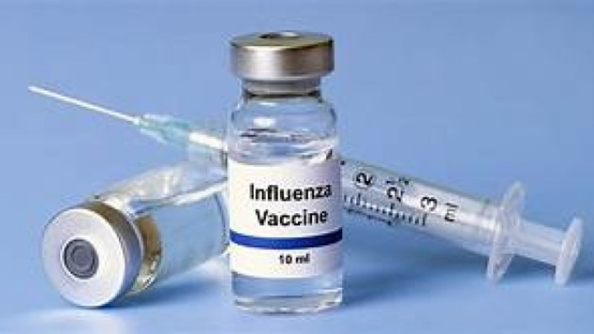

The Westwood Health Department is pleased to announce that a Flu Clinic will be held on Saturday, October 5, 2024 from 10am-2pm for residents age 3 and older outside in the parking area of Westwood High School.

This clinic will be run by Wegmans Pharmacy by appointment only, click here for an appointment
Link:
https://chat.eh.care/280c259028fc46a7b57b3511146f46b4?clinicId=126633

QR Code:


The day of the clinic you will need to bring a copy of your ID and insurance card. For more information, please contact pharmacywellnessne@wegmans.com or call (781) 234-0345

