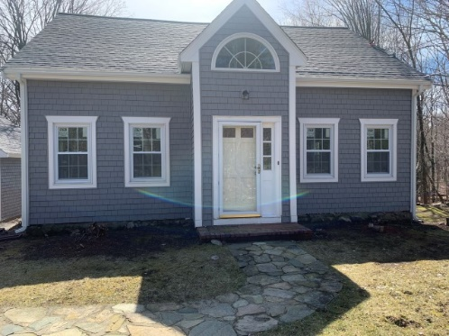
Affordable Properties in Westwood. Waitlist OPEN!

The Units
Westwood Housing Authority (WHA) and Westwood Affordable Housing Associates, Inc. (WAHA) contribute to the development and management of affordable housing in Westwood. WAHA, is an independent non-profit agency that manages the operation of numerous rental units and family homes located throughout town.

Features include:
- No pets allowed
- Smoke-free buildings
- Great schools
- On-site parking
- Walk to public transportation
- Washer & dryer included in most units

The Rents

Rent vary amongst WAHA properties however the rent will approximately be:

1 bedroom: $1,812 2 bedrooms: $2,013

3 bedrooms: $2,225 4 bedrooms: $2,387

Note: Tenant is responsible for all utilities including gas heat, hot water and cooking.

The Households
Household income cannot exceed the following limits:
Household size | 1 persons | 2 persons | 3 persons | 4 persons | 5 persons
Income limit (80% of Area Median Income) | $70,750 | $80,850 | $90,950 | $101,050 | $109,150
Additionally, households may be subject to credit and background checks. Negative information on either report does not automatically preclude your household from renting a unit.

The Process
To be considered for one of these units you must 1) fill out the “Ready Renter Pre-Application” if you have not already done so at: https://metrowestcd.org/renters/ready-renter-program/ and 2) contact Barbara at barbara@metrowestcd.org or 617-923-3505 x 8 to receive a Waitlist Entry Form.
TYY users please call 711.
For Reasonable Accommodations Requests or Language Assistance Call Barbara at 617-923-3505 x 8.
Creemos que la solicitude es muy extensa y complicada. Nos gustaria ayudarle a rellenarla. Por favor, póngase en contact con Barbara para fijar fecha de ayudarle a hacerlo. Puede llamarla al teléfono 617-923-3505 x 8.

