Town of Westwood

Household Bulk Collection Event

Week of October 11, 2021

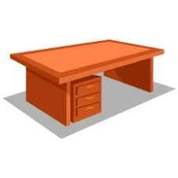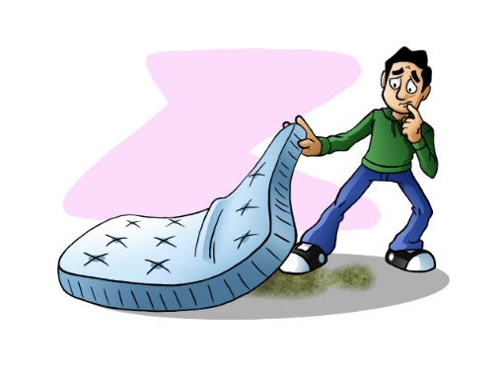

**Free Curbside pickup of ONE bulk item on your regular trash day**

* **Week of October 11th only (10/11-10/15/21)**
* **Item must be at your curbside by 7:00am on your regular trash collection day**
* **Only ONE item per household is allowed**
* **No appliances (nothing with a plug: TVs, lamps, computers, monitors, etc.)**
* **No construction waste, hazardous waste or metal items**

**WHAT ITEMS ARE ACCEPTED:**

* **Furniture piece (wood)**
* **Sofa/Loveseat**
* **Sectional Sofa (up to 3 pieces)**
* **Sleep Sofa (with metal)**
* **Desk or Door (wood)**
* **Mattress OR Box Spring**
* **Toilet OR Porcelain sink**
* **Bathtub – fiberglass**
* **Fence – wood** *(cut to length)
* **Wood swing set** *(cut to length)
* **Rug** *(cut to length)

*Cut to length – cut into 3 foot sections & tied in a bundle. Bundle cannot be more than 50 lbs. in total weight

**For more information contact** [**dpw@townhall.westwood.ma.us**](mailto:dpw@townhall.westwood.ma.us) **or 781-251-2587**