Town-wide Marked Crosswalk Evaluation

Technical Report For the

Town of Westwood, Massachusetts



Prepared For:

Town of Westwood

Department of Public Works

50 Carby Street

Westwood, MA 02090

Prepared by:

BETA Group, Inc.

315 Norwood Park South,

2nd Floor

Norwood, MA 02062

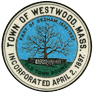

***PRELIMINARY DRAFT***

***September 2018***

Table of Contents

1. Introduction 1

***1.1*** ***What Constitutes a Pedestrian Crossing?*** 1

***1.2*** ***Study Objectives and Outline*** 2

2. Crosswalk Identification and Evaluation Criteria 2

***2.1*** ***Crosswalk Identification*** 2

***2.2*** ***Evaluation Criteria*** 3

3. Data Collection & Summary of Findings 9

***3.1*** ***Signage*** 9

***3.2*** ***Pavement Markings*** 12

***3.3*** ***ADA Curb Ramp Evaluation*** 19

***3.4*** ***Sight Distance*** 29

***3.5*** ***In-Crosswalk Safety Evaluation*** 31

***3.6*** ***Geometric Considerations*** 33

***3.7*** ***Additional Considerations/Observations*** 37

4. Cost Estimate 41

**Tables**

|  |  |
| --- | --- |
| Table 1 | Sign Improvement Recommendation Summary |

**Maps**

|  |  |
| --- | --- |
| Map 1 | Tier Buffer Map |
| Map 2 | Crosswalk Locations Tier Map |
| Map 3 | Sign Improvements at Crosswalk Locations |
| Map 4 | Pavement Marking Improvements at Crosswalk Locations |
| Map 5 | Tier 1 Curb Ramp Improvements at Crosswalk Locations |
| Map 6 | Tier 2 Curb Ramp Improvements at Crosswalk Locations |
| Map 7 | Tier 3 Curb Ramp Improvements at Crosswalk Locations |
| Map 8 | Geometric Intersection Improvements at Crosswalk Locations |

**Figures**

|  |  |
| --- | --- |
| Figure 1 | Curb Ramp Compliance Per Location |
| Figure 2 | In Crosswalk Evaluation |
| Figure 3 | Pond Street at Circuit Avenue/Clapboardtree Street |
| Figure 4 | 837 High Street |
| Figure 5 | Nahatan Street at High Street |
| Figure 6 | Reservoir Road at Spruce Street |
| Figure 7 | Hartford Street at Kingswood Road/Mill Street |

**Photos**

|  |  |
| --- | --- |
| Photo 1 | Pedestrian School Crossing Signs |
| Photo 2 | Pedestrian Crossing Sign |
| Photo 3 | Overlapping Pedestrian Signs |
| Photo 4 | Gay Street Heading Southbound Towards Crosswalk |
| Photo 5 | High Street Heading Southbound Approaching Pond Street |
| Photo 6 | Pond Street Northbound Approaching Crosswalk |
| Photo 7 | Sight Line for a Pedestrian Looking to North and South on Pond Street from Ramp |
| Photo 8 | NStar Way Eastbound Approaching Marymount Avenue |

**List of Appendices**

|  |  |
| --- | --- |
| Appendix A | Field Photos and Notes |
| Appendix B | Evaluation Matrix |
| Appendix C | Cost Estimate |
|  |  |
|  |  |
|  |  |

**This Page Intentionally Left Blank.**

1. **Introduction**

BETA Group, Inc was retained by the Town of Westwood to evaluate existing marked crosswalk locations for overall pedestrian safety and compliance with engineering, safety, and mobility standards.

The purpose of the evaluation is to create a comprehensive program enhancing safety and accessibility at pedestrian crossing locations throughout the Town. This study evaluates existing locations and provides recommendations to achieve the end goal.

* 1. ***What Constitutes a Pedestrian Crossing?***

The Manual on Uniform Traffic Control Device (MUTCD) defines two types of pedestrian crossings:

1. Unmarked Crossing -

The definition of an unmarked crosswalk per the MUTCD is: “That part of a roadway at an intersection included within the connections of lateral lines of the sidewalks on opposite sides of the highway measured from the curbs or in the absence of curbs, from the edges of the traversable roadway, and in the absence of sidewalk on one side of the roadway, that part of a roadway included within the extension of the lateral lines of the sidewalk at right angles to the center line…”

1. Marked Crossing -

The definition of a marked crosswalk per the MUTCD is:”…any portion of a roadway at an intersection or elsewhere distinctly indicated as a pedestrian crossing by pavement marking lines on the surface, which might be supplemented by contrasting pavement texture, style or color.”

This report focuses on marked crosswalk locations.

Crosswalk markings at signalized, yield and stop controlled intersections are provided to define a path for and guide pedestrians across the roadways. At uncontrolled locations, markings are used in conjunction with signs and other measures to alert drivers of the potential presence of pedestrians.

* 1. ***Study Objectives and Outline***

The scope of the study consisted of the following six-step process:

1. Identify and prioritize existing marked crosswalks to be evaluated as part of the study.
2. Conduct site visits at each location to evaluate/record existing conditions.
3. Summarize field observations and data to determine conformity with:
   * the Manual on Uniform Traffic Control Devices (MUTCD)
   * Safety
   * Americans with Disabilities Act (ADA)
4. Develop recommended improvements, cost estimates and conceptual designs (where applicable) for each location.
5. Establish short and long term capital improvement plan.
6. Present findings to key stakeholders and submit final report.
7. **Crosswalk Identification and Evaluation Criteria**
   1. ***Crosswalk Identification***

Crosswalks were located utilizing a combination of the ESRI, DigitalGlobe and available Google Aerial photography. There were found to be **202 marked crosswalks** Town-wide.

These existing crosswalk locations were prioritized based on their proximity to schools and public facilities, and grouped into three tiers described as follows:

* **Tier 1 - 43 Locations (77 crosswalks)**
  + Locations within ¼ mile buffer proximity to schools.
* **Tier 2 - 36 locations (53 crosswalks)**
  + Locations within ¼ mile buffer proximity to public facilities (ie recreation facilities, park, etc.).
* **Tier 3 - 44 locations (72 crosswalks)** 
  + Locations more than ¼ from schools and public facilities.

Tier 1 and Tier 2 locations often overlapped due to the proximity of schools and public facilities. Tier 1 locations took precedence over any locations also within the Tier 2 buffer and were included as part of Tier 1 instead of Tier 2.

Map 1 shows the Tier Buffer map which outlines the Tier 1 and Tier 2 buffer areas. Tier 3 locations are sporadically situated throughout the remainder of the map. Map 2 shows all of the crosswalk locations color coded by Tier.

* 1. ***Evaluation Criteria***

The project team established a step-by-step process to evaluate each marked crosswalk location. The following evaluation criteria were documented at each location:

* Existing Signage
  + Location
  + General Condition
  + Content
  + Conformance with the MUTCD
* Pavement Markings
  + Presence
  + Condition
  + Conformance with the MUTCD
* ADA Curb Ramp Evaluation
  + Ramp Condition
  + Orientation
  + Transition slopes
  + Level landing
  + Ramp opening width
  + Obstructions
  + Detectible Warning Panel
  + Condition of Panel
* Sight Distance (unsignalized and mid-block crosswalks only)
* In-Crosswalk Safety Evaluation
  + Pavement Condition
  + ADA complaint Catch Basin
  + Recessed Utility Identification
  + Elevation difference between ramp and pavement
  + Crossing Distance
* Additional Considerations (relevancy, reconfiguration, lighting)

**This Page Intentionally Left Blank**

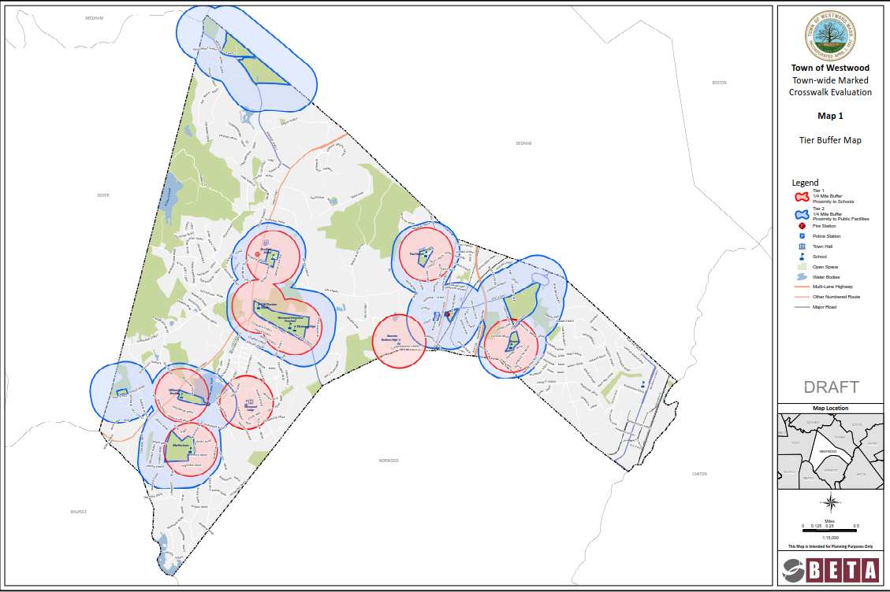

Map : Tier Buffer Map

**This Page Intentionally Left Blank**

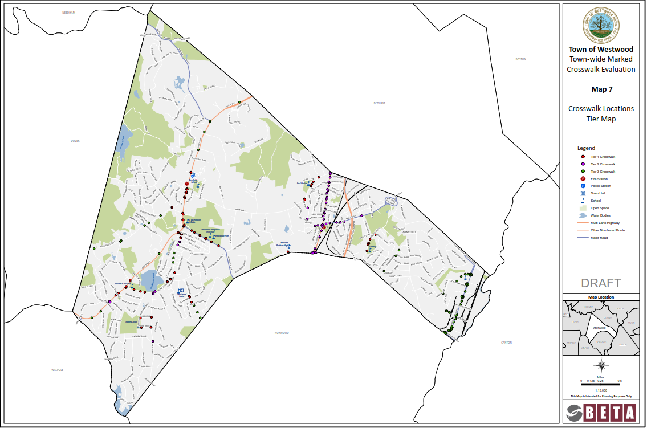

Map : Crosswalk Locations Tier Map

**This Page Intentionally Left Blank**

1. **Data Collection & Summary of Findings**

Data collection commenced in June of 2018 and continued through July of 2018. Each crosswalk was evaluated and the data summarized. The evaluation matrix for each tier and supplemental sheets are provided in the Appendix. The findings for each of evaluation criteria outlined in section 2.2 are as follows and by tier:

* 1. ***Signage***

Generally, the Town of Westwood has MUTCD compliant pedestrian signage at crosswalk locations throughout Town. It is evident that the Town has recently updated or installed many new pedestrian signs.

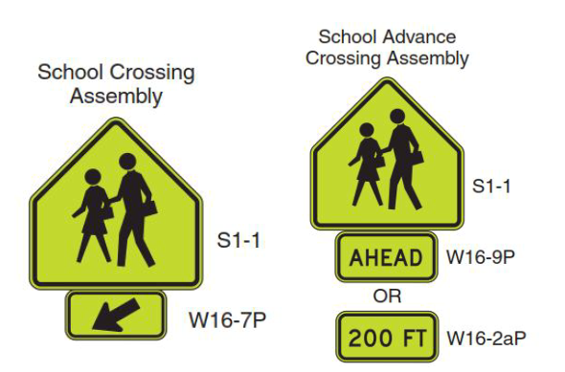

Photo : Pedestrian School Crossing Signs

Per the MUTCD, the School Crossing assemblies consist of a school sign (S1-1) with a diagonal downward arrow (W16-7P) at the crosswalk and a school sign (S1-1) supplemented with either “Ahead” (W16-7P) or “200 FT” (W16-2aP) plaques in advance of the crossing if provided. School Crossing assemblies should only be used adjacent to schools and along school pedestrian routes.

Otherwise, crosswalk signing should consist of Pedestrian Crossing signs (W11-2) with arrow plaques (W16-7P) at the crosswalk and W11-2 signs with either “Ahead” (W16-7P) or “200 FT” (W16-2aP) plaques in advance of the crossing.

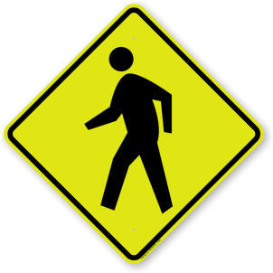

Photo : Pedestrian Crossing Sign (W11-2)

School pedestrian route information was not included in this evaluation. Crossing locations not adjacent to schools with School Crossing assemblies were assumed to be school pedestrian routes for purposes of this project and those signs were maintained or are proposed to be replaced in kind.

Table 1 summarizes the overall number of crosswalk locations where signage should be removed, replaced, or installed to meet MUTCD standards throughout the Town. Some of the locations have a combination of sign needs.

Table : Sign Improvement Recommendation Summary*

|  |  |  |  |
| --- | --- | --- | --- |
| **Type of Sign Improvement** | **Tier 1 Locations** | **Tier 2 Locations** | **Tier 3 Locations** |
| Install Advanced Ped Sign Assembly (New Signs) | 23 | 12 | 6 |
| Install At Crosswalk Ped Sign Assembly (New Signs) | 17 | 10 | 4 |
| Install STOP/Yield Sign (New) | 13 | 2 | 13 |
| Remove & Reset Sign Panels | 5 | 7 | 0 |
| Remove Existing Signs | 12 | 2 | 1 |

*These numbers refer to the number of crosswalk locations where signage improvements are recommended, not the quantity of signs. Specific sign quantity information is provided by Tier in the subsequent pages and in the Appendix.

**Tier 1**

Tier 1 consists of school related crosswalk locations. Based on the field data collection, 26 of the 77 crosswalks would benefit from additional pedestrian signage. Advanced signage is not necessary for all marked crosswalk locations, but should be installed where there is a sight distance issue or a crosswalk is unexpected. Many of the locations are in need of “Ahead” or downward arrow plaques. For the purposes of this evaluation, replacing the entire sign assembly for sign condition, retroreflectivity, and consistency is recommended; however, existing posts may be retained.

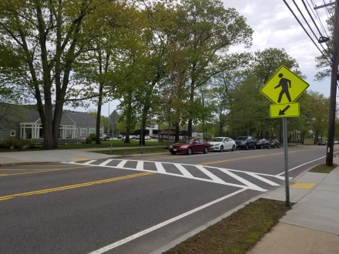

Photo : Overlapping Pedestrian Signs

Several pedestrian crossing signs, primarily along Nahatan Street, are overlapping on posts and several signs at and in advance of crossings were missing the arrow and “Ahead” signs. Supplemental signs must be provided on both sets of pedestrian signs and signs should not overlap.

Adjacent to the school property along Nahatan Street there are several marked crosswalks in close proximity. Therefore, advanced School Crossing sign assemblies are not necessary in advance of every crosswalk and advanced signs that could be removed are noted in the Appendix.

STOP signs and yield signs were missing on some side street approaches to an intersection and a school driveway. STOP signs and yield signs should be installed on the side street approaches where appropriate.

STOP signs should be considered at the following locations to supplement existing stop lines:

* Greenacre Road at Pond Street
* Laura Lane at Gay Street
* Pond Plain Road at Pond Street
* Winter Street at Autumn Drive

STOP Signs should be considered at the following locations where they are not provided today:

* First Baptist Church Westwood at High Street
* Church Street at High Street
* Lake Shore Drive at Pond Street
* Gay Street at Hanlon School driveway
* Phillips Brook Road at Downey Street
* Cedar Hill Drive at Gay Street

Yield signs should be considered at the following uncontrolled channelized right turn locations with a marked crosswalk:

* Gay Street at Pine Lane
* Hartford Street at High Street
* Nahatan Street at High Street (supplemental sign on left-side of approach)

**Tier 2**

Tier 2 consists of crosswalk locations near public facilities. Overall, the signage in Tier 2 is in very good condition and appropriately located. Based on the field data collection, 12 of the 53 crosswalks would benefit from additional pedestrian signage. Two locations in Tier 2 contained overlapping signs. Three locations were missing the “Ahead” supplemental signs on advanced sign assemblies.

A STOP sign should be considered at the 327 Washington Street driveway to supplement the STOP line.

**Tier 3**

Based on the field data collection, 7 of the 72 crosswalks would benefit from additional pedestrian signage.

Two locations along Hartford Street provide pedestrian sign assemblies that are in good condition; however, the panel colors are yellow. The signs at this location should be replaced with the fluorescent yellow-green background for consistency with the rest of the Town pedestrian signing.

A STOP sign should be considered at the Hartford Street and Burgess Avenue crosswalk to supplement the stop line.

STOP signs are recommended at the following locations where they do not exist today:

* Eastman Avenue at Pond Street
* Stanford Drive at High Street
* Gloucester Road and High Street
* Warwick Drive at Hartford Street
* Wessex Drive at Hartford Street

Additional locations in Tier 3 do not provide STOP signs, however, STOP signs are not necessary due to available sight distance and/or traffic volume. A few of the new STOP signs called for in Table 1 for Tier 3 currently have STOP signs but were found to have stickers on the sign resulting in failed MUTCD compliance. If the stickers cannot be removed without damaging the signs, the signs should be replaced. These locations are noted on the evaluation matrix found in the Appendix.

Map 3 shows the crosswalk locations where signing improvements are recommended.

* 1. ***Pavement Markings***

Overall, pavement markings at crosswalks are in good condition town-wide.

The Town utilizes various styles of crosswalk markings: ladder, continental, zebra and parallel lines. While all of these styles conform to the MUTCD, a lack of uniformity may confuse drivers and pedestrians. Through discussions with Town staff, it is understood that the Town intends to provide a consistent continental type marking at all marked crosswalks moving forward.

**Tier 1**

Overall, the crosswalk markings are in good condition. New or revised pavement markings at the following locations would be beneficial in meeting MUTCD compliance and increasing visibility for drivers:

* *Gay Street at Pine Lane* - Provide new center line and shoulder pavement markings adjacent to the Gay Street crosswalk.
* *60 Nahatan Street -* Extend the length of crosshatching located on the east side of the crosswalk from 13 feet to the minimum standard 20 feet. In order to comply with the MUTCD, the crosshatch markings should be replaced with white markings and rotated 90 degrees to slant away from traffic.
* *Nahatan Street at Bonney Street* – Provide 20 feet of crosshatching on the west side of the crosswalk and provide white crosshatch markings and rotated 90 degrees to slant away from traffic.
* *Nahatan Street at French Street* - In order to comply with the MUTCD, the crosshatch markings should be replaced with white markings and rotated 90 degrees to slant away from traffic.

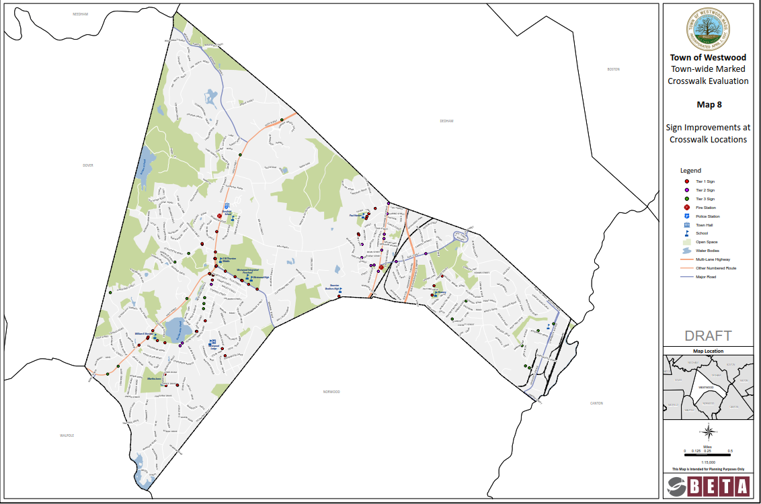

Map : Sign Improvements at Crosswalk Locations

**This Page Intentionally Left Blank**

Seven stop controlled crosswalk locations are missing stop lines. It is recommended that stop lines be installed to supplement STOP signs and provide a designated place for vehicles to stop in advance of a crosswalk for pedestrian safety at the following locations:

* First Baptist Church driveway at High Street
* Church Street at High Street
* Lake Shore Drive at Pond Street
* Gay Street at Hanlon School driveway
* Martha Jones Road at Oak Street
* Phillips Brook Road at Downey Street
* Cedar Hill Drive at Gay Street

Yield markings are not provided at the channelized right-turn movement on Nahatan Street at High Street. It is recommended that these marking be installed to supplement the yield sign.

Yield markings are recommended to supplement yield signs at the following locations pending the installation of yield signs:

* Gay Street at Pine Lane
* Hartford Street at High Street

**Tier 2**

Updating crosswalk pavement markings would provide increased visibility and pedestrian safety at the following three locations:

* East Street at Carroll Avenue
* 327 Washington Street
* Washington Street at Clapboardtree Street

In order to comply with the MUTCD, 20 feet of white crosshatch markings slanted away from traffic should be provided on each side of the crosswalk at 157 Washington Street.

**Tier 3**

Updated crosswalk pavement markings would provide increased visibility and pedestrian safety at the following locations:

* Conant Street at High Street
* Stanford Street at High Street
* Hartford Street at Burgess Avenue
* Harvard Street at driveway
* N Star Way near Marymount Avenue
* University Avenue at Canton Street
* University Avenue at Yale Street
* University Avenue at Rosemont Road
* Wessex Drive at Hartford Street
* Blue Hill Drive at University Avenue
* University Avenue at several driveways along the corridor

Three stop controlled crosswalk locations are missing stop lines. It is recommended that stop lines be installed to supplement STOP signs and provide a designated place to stop in advance of a crosswalk at the intersection at the following locations:

* Mill Street at Hartford Street
* Sylvan Road at Pond Street
* University Avenue driveway for 348-410 University Avenue

Stop lines are recommended to supplement STOP signs at the following locations pending the installation of STOP signs:

* Eastman Avenue at Pond Street
* Stanford Drive at High Street
* Gloucester Road and High Street
* Warwick Drive at Hartford Street
* Wessex Drive at Hartford Street

Map 4 shows the crosswalk locations where additional or enhanced pavement markings are recommended.

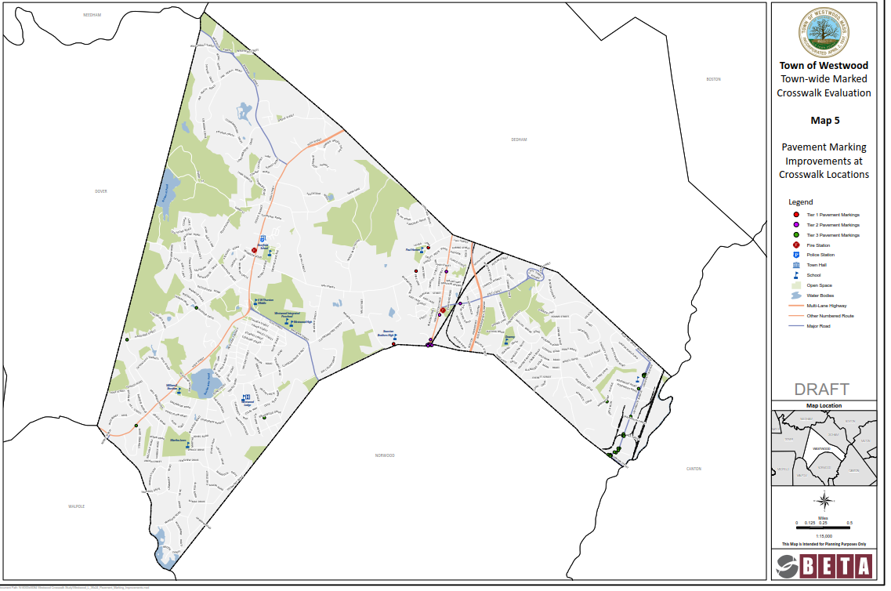

Map : Pavement Marking Improvements at Crosswalk Locations

**This Page Intentionally Left Blank**

* 1. ***ADA Curb Ramp Evaluation***

ADA compliance standards for accessible ramps takes into consideration ramp condition, orientation, presence, transition slopes, landing width and slope, ramp openings top and bottom, obstructions, and the presence and condition of detectable warning panels. For purposes of this study, the following ramp data was collected for pedestrian safety and ADA compliance:

* Smart level to obtain the level landing and transition slopes.
* Ramp opening width if appeared to be narrower than 3 feet.
* Presence of a detectable warning panel and condition.
* Clear space within the crosswalk.

Based on the overall review, 76 crosswalk locations out of 202 provide two compliant ramps which do not need modification. The remaining 126 locations have one or more ramps that either do not fully comply with the ADA standards or ramps are not provided.

Figure 1 presents the overall ramp compliance summary at the locations inventoried as part of Tier 1, Tier 2 and Tier 3.

Figure : Curb Ramp Compliance Per Location

**Tier 1**

Twenty-one of the 77 crosswalk locations in Tier 1 contain ramps that are fully compliant. Of the fifty-six crosswalk locations with one or more non-compliant ramps, lack of detectable warning panel was the sole cause for ADA non-compliance at 16 locations. These ramps were otherwise compliant. The warning panel can be installed without significant adjustments to the ramp and at low cost.

A total of 16 new pedestrian ramps are required where none exist today at the following eight crosswalk locations:

* Gay Street and Croft Regis Road
* Hartford Street and High Rock Street
* High Rock Street and Hartford Street
* High Street and Mill Street
* Mill Street and High Street
* Laura Lane and Gay Street
* Martha Jones Road and Reservoir Road
* Phillips Brook Road and Downey Street

The remaining 32 crosswalk locations have ramps which failed ADA compliance due to the factors identified at the beginning of this section. The most consistent reason for non-compliance is due to a ramp transition slope greater than 8.33% and/or the lack of a level landing.

**Tier 2**

Thirteen of the 53 crosswalk locations in Tier 2 contain ramps that are fully compliant. Of the 40 crosswalk locations with one or more non-compliant ramps, lack of detectable warning panel was the sole cause for ADA non-compliance at one location. These ramps were otherwise compliant.

A total of three new pedestrian ramps are required where none exist today at the following two crosswalk locations:

* Washington Street at the fire station driveway. The crosswalk currently leads directly into the fire station driveway.
* Fensview Drive at Oak Street

The remaining 37 crosswalk locations have ramps which failed ADA compliance due to the factors identified at the beginning of this section. The most consistent reason for non-compliance is due to a ramp transition slope greater than 8.33% and/or the lack of a level landing.

**Tier 3**

Forty-two of the 72 crosswalk locations in Tier 3 contain ramps that are fully compliant. Of the 30 crosswalk locations with one or more non-compliant ramps, lack of detectable warning panel was the sole cause for ADA non-compliance at 10 locations. The majority of ramps in this Tier are part of the recent University Station project and related work. Therefore, many of the ramps in this tier have been constructed within the last few years.

A total of 8 new pedestrian ramps are required where none exist today at the following four intersections:

* Hartford Street and Kingswood Road (2)
* Hartford Street and Mill Street (2)
* Stanford Drive and High Street (1)
* University Avenue and Yale Street (3)

The remaining 16 crosswalk locations have ramps which failed ADA compliance due to the factors identified at the beginning of this section. The most consistent reason for non-compliance is due to a ramp transition slope greater than 8.33% and/or the lack of a level landing.

Maps 5 through 7 show the ramp improvement locations per tier with the associated type of non-compliance.

**This Page Intentionally Left Blank**

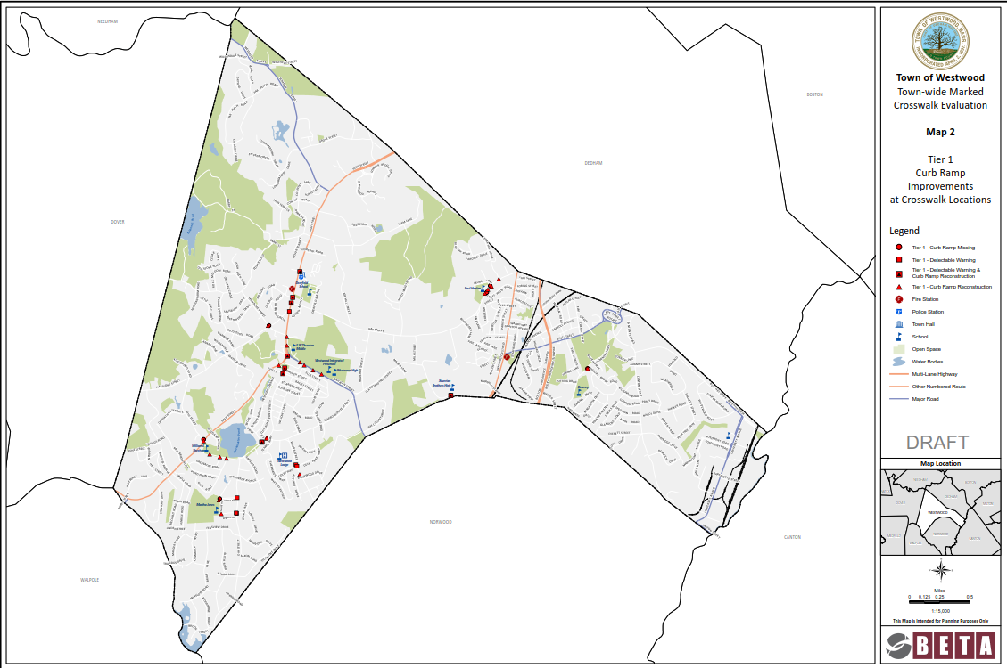

Map : Tier 1 Curb Ramp Improvements at Crosswalk Locations

**This Page Intentionally Left Blank**

Map : Tier 2 Curb Ramp Improvements at Crosswalk Locations

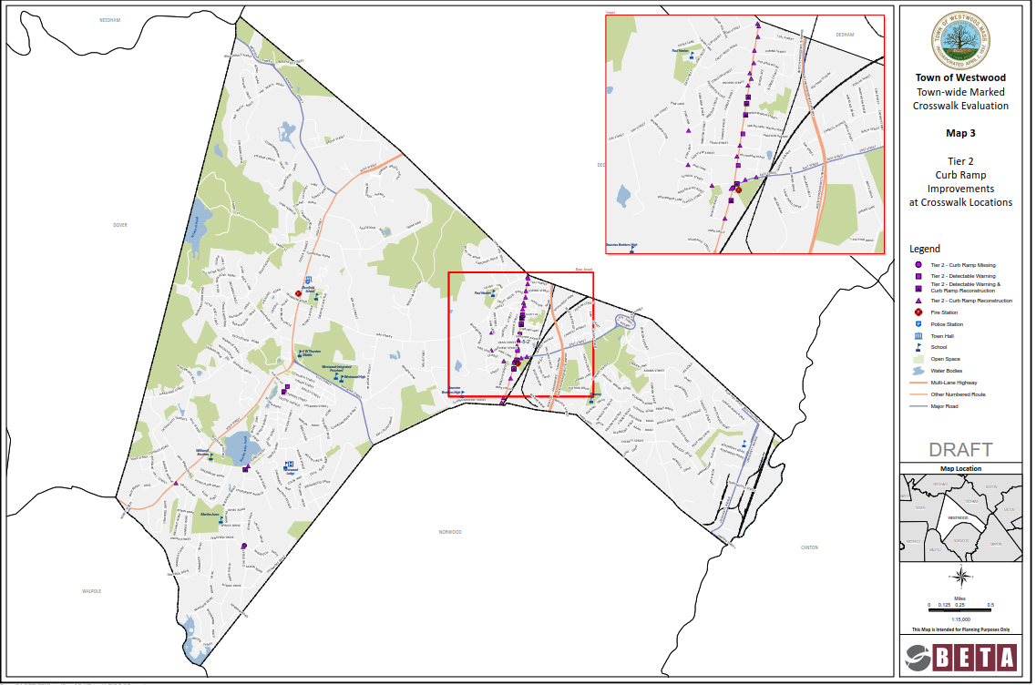

**This Page Intentionally Left Blank**

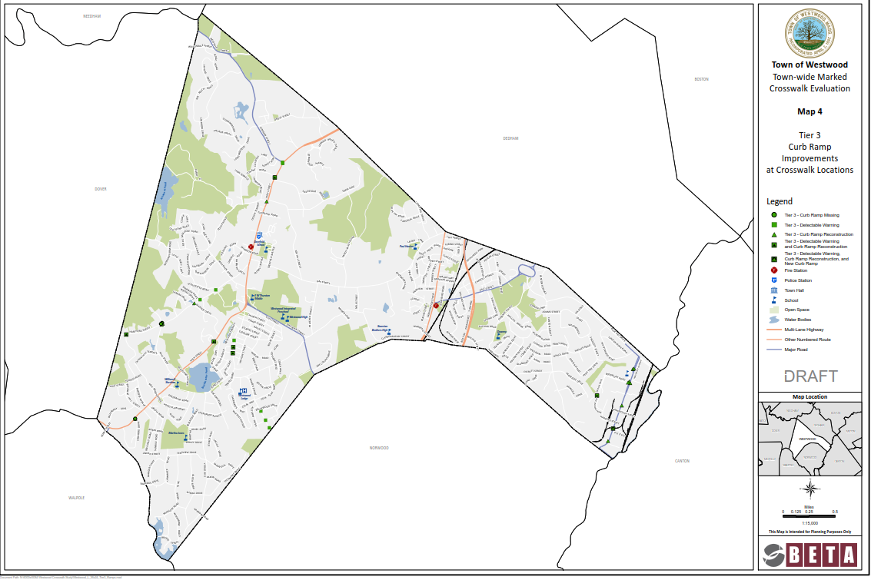Map : Tier 3 Curb Ramp Improvements at Crosswalk Locations

**This Page Intentionally Left Blank**

* 1. ***Sight Distance***

The installation of signing at and/or in advance of a crosswalk increases the driver’s visibility of a pedestrian crossing at unsignalized and mid-block marked crossings.

**Tier 1**

Several crosswalk locations have limited sight distance of a STOP sign or crosswalk due to vegetation and/or roadway alignment.

To improve pedestrian visibility and safety, vegetation trimming should be maintained and additional pedestrian crossing signing on the opposite side of the roadway is recommended at the following locations. Supplemental signing on the opposite side of the roadway would additionally improve driver attention to the crossing.

* **Gay Street at Pine Lane**

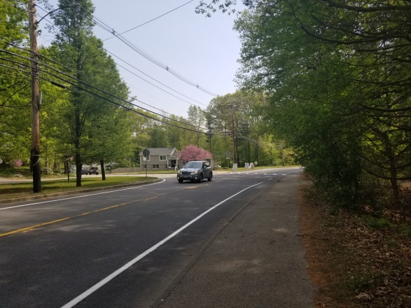

Photo : Gay Street Heading Southbound Towards Crosswalk

* **Pond Street at High Street**

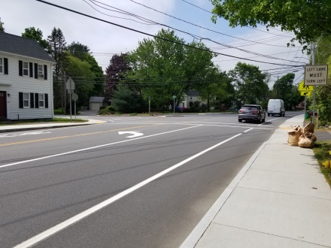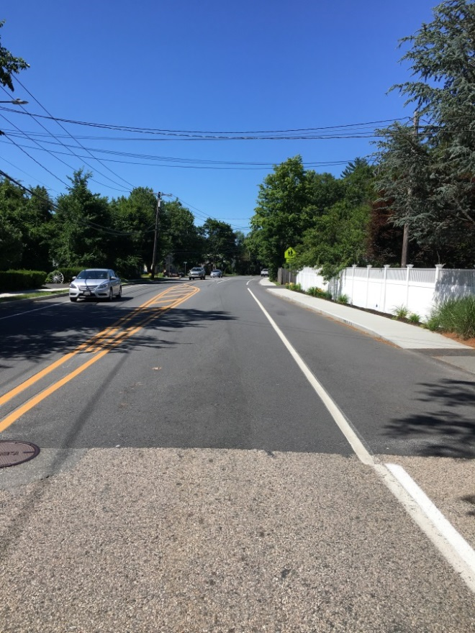

Photo : High Street Heading Southbound Approaching Pond Street

* **Pond Street at Martingale Lane**

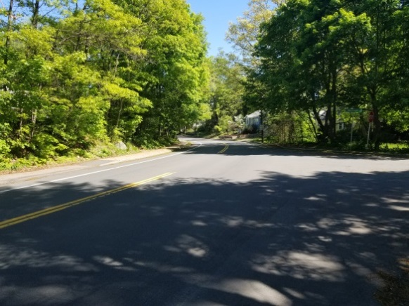

Photo : Pond Street Northbound Approaching Crosswalk

The posted speed limit is 30 miles per hour (MPH) approaching the crosswalk. The available stopping sight distance is 240 feet approaching the crosswalk in the northbound direction which is sufficient for a design speed of approximately 34 MPH. The design speed is based on the 85th percentile speed of vehicles.

Based on observations, the travelling speeds of vehicles in the vicinity of the crosswalk appeared to exceed the posted speed limit. A speed study is recommended in the area to validate these observations. Pedestrian volume data collection is also recommended to validate the crosswalk. Based on the results, the Town may consider alternative measures to reduce travelling speeds such as a pushbutton activated LED pedestrian crosswalk sign assembly similar to those currently in Town, a Rectangular Rapid Flashing Beacon (RRFB), or removal of the crosswalk.

In addition to the speed concern, the shade created on the pavement by the overhead tree line significantly impacts the visibility in the area of the crosswalk. Advanced signing, signing at the crosswalk and vegetation trimming should be provided at this location.

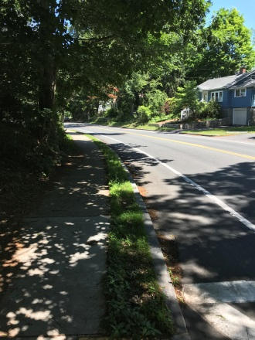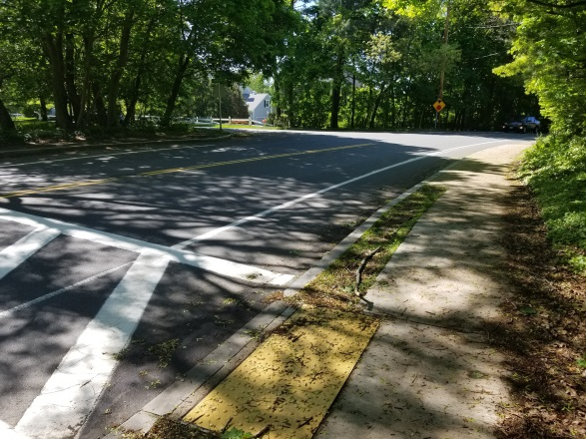

Photo : Sight Line for a Pedestrian Looking to North and South on Pond Street from Ramp

Additional crosswalk locations where vegetation trimming would improve sight distance and/or STOP sign visibility are:

* Baker Street at Nahatan Street
* Barlow Lane at High Street
* Church Street at Pond Street
* Gay Street at Pine Street
* Oak Street at Spruce Street
* Spruce Street at oak Street
* High Street at Pond Street
* Martha Jones Road at Reservoir Road
* Clapboardtree Street at Xaverian School

**Tier 2**

Trimming vegetation at the following locations would improve sight distance and/or STOP sign visibility.

* School Street in front of the School Street playground
* Grafton Avenue at Washington Street
* Hooper Street at Washington Street
* Pond Street at Willow Farm Road
* School Street at Schaeffer Avenue
* 258 Washington Street
* Wentworth Street at Washington Street

**Tier 3**

Trimming vegetation at the following locations would improve sight distance and/or STOP sign visibility.

* Dover Road at High Street
* Eastman Avenue at Pond Street
* Stanford Drive at High Street
* Winter Street at Briarwood Drive
* Winter Street at Lasalle Road
  1. ***In-Crosswalk Safety Evaluation***

Several additional factors were considered regarding pedestrian safety at and within crosswalks. Additional factors evaluated within each crosswalk include pavement condition, ADA catch basin compliancy, recessed/raised utilities, non-ADA compliant elevation differences between ramps and roadway pavement, and the length of the crosswalk.

Recessed/raised utilities within crosswalks include gate boxes or manhole covers which are not flush with the pavement and are above or below the pavement by more than ¼ inch. The following are locations by tier where gate boxes or manhole covers should be adjusted:

**Tier 1**

* Spruce Drive at Oak Street

**Tier 2**

* Brookfield Road at Washington Street
* Fairview Street at Washington Street
* Grafton Avenue at Washington Street
* Hooper Street at Washington Street

**Tier 3**

* Sylvan Road at Pond Street
* Forbes Road at Cushing Road
* University Avenue at Canton Street
* University Avenue at Rosemont Road
* Winter Street at Thompson Avenue

Pavement conditions, ADA catch basin compliancy, recessed utilities, and locations where there are non-ADA compliant elevation differences between ramps and roadway pavement are provided in the Appendix and also quantified by tier in Figure 2.

Figure : In Crosswalk Evaluation

The installation of a median at crosswalk locations that have longer crosswalks would provide a refuge area for pedestrians crossing the longer distance. Crosswalks longer than 50 feet were noted and considered for medians on a location by location basis and noted in the documents provided in the Appendix.

* 1. ***Geometric Considerations***

Bump Out/Curb Extension

For this evaluation a “bump out” is a curb extension used to reduce the crosswalk crossing length which provides a safer crossing for pedestrians.

**Tier 1**

The shoulder widths along Nahatan Street and Pond Street in the vicinity of the crosswalk location listed below are between 8-10’ wide and bump outs are recommended.

* Nahatan Street at Bonney Street
* Nahatan Street at French Street
* 60 Nahatan Street
* 530 Pond Street

A stone wall impedes the ADA compliance of one pedestrian ramp at the Pond Street at Church Street crosswalk and a bump out should be considered:

**Tier 2**

The shoulder widths are approximately 8 feet on both sides of the crosswalk located at 157 Washington Street and bump outs are recommended at this location.

**Tier 3**

There are not any Tier 3 crosswalk locations with proposed bump outs.

Intersection Reconstruction

Based on field data collection and observation, the following locations should be considered for improvement measures more significant than signing, pavement markings, ramps, and bump outs.

**Tier 1**

Pond Street at Circuit Avenue/Clapboardtree Street

The existing signing at the intersection is not MUTCD compliant and the pavement markings are not compatible with the signing. The following graphic shows an intersection design option which provides a refuge area for pedestrians crossing Pond Street while maintaining the existing lane configuration. The refuge area would improve pedestrian safety by reducing the pedestrian crossing distance and providing a vertical device to protect the pedestrian.

Based on our observations, the intersection appears to generate a significant amount of traffic, including large trucks. To fully understand traffic conditions at the intersection, the recommendation is to collect 12-hour traffic volume data at the intersection and conduct a traffic signal warrant analysis to evaluate if traffic signal criteria are met for any of the signal warrants for future signalization.

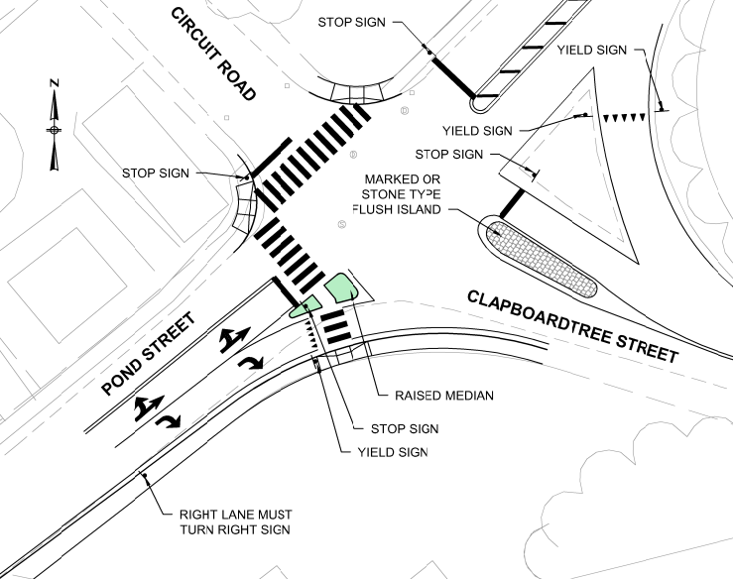

Figure : Pond Street at Circuit Avenue/Clapboardtree Street

837 High Street

Based on our observations, there are high vehicular speeds with low compliance for yielding to pedestrians at this location. Pedestrian crossing signs are not provided and the crosswalk is angled with no refuge area. The following graphic shows a pedestrian crossing design option which includes signing and a raised median surrounding the refuge area while maintaining the necessary turning area for busses exiting the school driveway destined southbound on High Street.

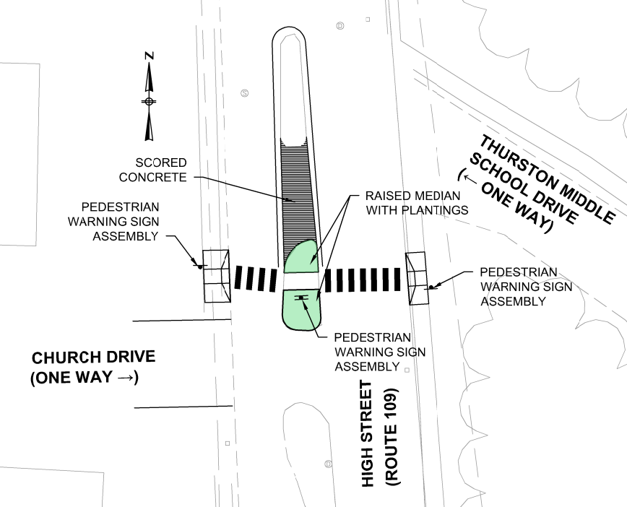

Figure : 837 High Street

High Street at Nahatan Street

This intersection currently consists of four crosswalks connecting from one side of the Nahatan Street approach to the other. The design option below reduces the number of pedestrian crossings from four to three and extends the northern curbline to provide more of a 90 degree approach for vehicles turning right onto High Street northbound. This design would significantly lower speeds of those vehicles, requiring a complete stop rather than a yield. Although this design improves pedestrian safety, with the elimination of one pedestrian crossing and providing a stop control for right-turning vehicles, this option would impact the delay and queuing experienced on the Nahatan Street approach. Traffic data collection is recommended at the intersection to determine delay and queue impacts to the intersection based on this design option.

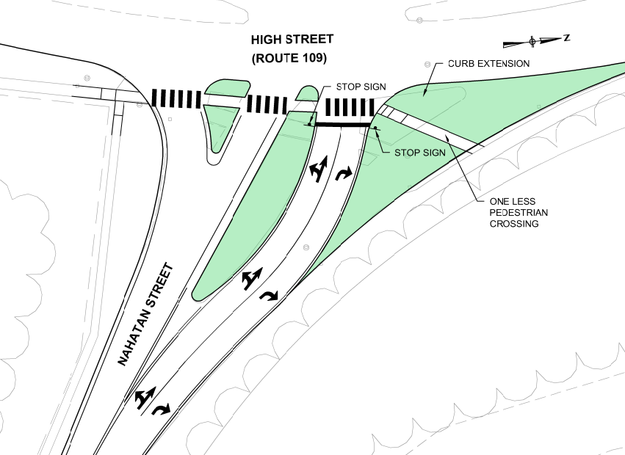

Figure : Nahatan Street at High Street

Reservoir Road/Martha Jones School at Spruce Drive

This location currently has a non-conventional crosswalk configuration and the pedestrian ramps need to be reconstructed. The following graphic shows a pedestrian crossing design option which maintains the existing edge of pavement and provides a more conventional crosswalk configuration across each street individually.

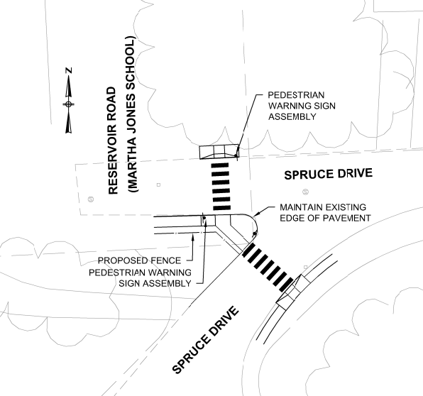

**Figure 6: Reservoir Road at Spruce Drive**

**Tier 2**

There are no proposed intersection reconstruction locations for Tier 2.

**Tier 3**

Hartford Street at Kingswood Road/Mill Street

This intersection lacks accessible ramps at the crosswalks. The sight distance is very limited due to the presence of a very large tree obstructing the view of a pedestrian on the north side of Hartford Street and for a vehicle approaching from the east. Therefore, the proposed intersection layout shifts the crossing to increase visibility for both the pedestrian and vehicle and improves the accessible ramps to meet ADA guidelines.

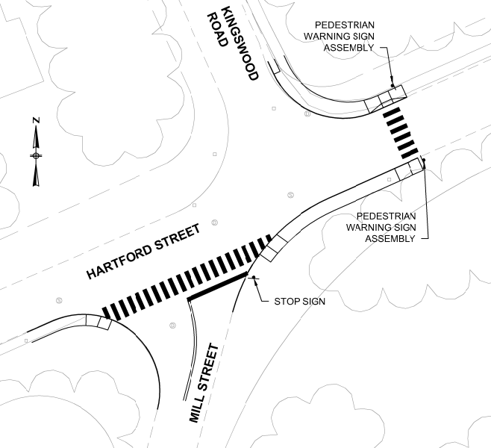

Figure : Hartford Street at Kingswood Road/Mill Street

Crosswalk locations with suggested geometric improvements are shown in Map 8.

* 1. ***Additional Considerations/Observations***

During the field data collection process additional observations were made and assessed including the relevancy, reconfiguration and lighting of each crosswalk.

Relevancy

School Street Mid-Block Crosswalk

This crosswalk connects the north side of School Street to the School Street Playground. The sidewalk on the north side extends from Washington Street to the crosswalk and then ends. This crosswalk is located approximately 250 feet west of a signalized crosswalk and 185 feet east of an unsignalized crosswalk. Pedestrian volume data was not collected as part of this evaluation, however, pedestrians approaching the crosswalk from the east could cross at the Washington Street signalized crosswalk. Pedestrians approaching from the west could cross at the School Street and Schaeffer Avenue crosswalk. Sidewalk is provided on the west side of Schaeffer Street and south side of School Street. In addition, the visibility of the crosswalk markings is hindered by overhanging trees and pedestrian signs are not provided at the crosswalk. Consideration should be given to removing the crosswalk at this location considering pedestrians that would use this crosswalk are able to cross at the signalized crossing to the east.

1 Oak Street just south of Pond Street

This is a mid-block crosswalk located approximately 70 feet to the south of the crosswalk at the intersection of Oak Street and Pond Street. This is a redundant crosswalk location and sight distance is limited. Consideration should be given to removing the crosswalk at this location.

Reconfiguration

Pond Street just west of Arcadia Road

The existing mid-block crosswalk is located approximately 20 feet to the west of Arcadia Road. People destined to cross at Arcadia Road from the east are unlikely to walk past the intersection to cross at the mid-block location. Relocating the crosswalk to the intersection of Arcadia Road would improve the expectancy of a crosswalk and which increases pedestrian safety.

NStar Way(Station Drive) near Marymount Avenue

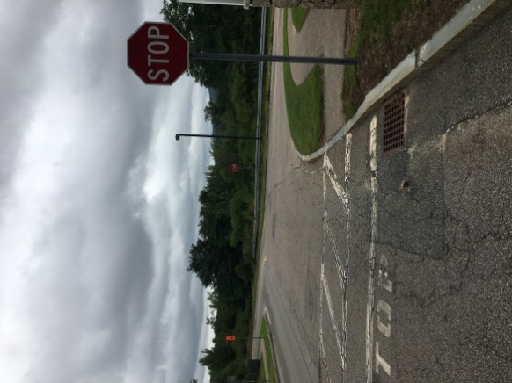

Photo : NStar Way Eastbound Approaching Marymount Avenue

A stop sign is installed approximately 30 feet west of Marymount Avenue on NStar Way at a marked crosswalk for what appears to be stopping vehicles for the crosswalk only. The westbound approach to the crosswalk is uncontrolled. The pavement markings are faded at the crosswalk and pedestrian signs are not provided at or in advance of the crossing for the uncontrolled NStar Way approach. This approach has limited sight distance due to the vertical and horizontal alignment. Pedestrian activity at this location does not appear to be consistent and during field observation vehicles were not heeding the stop sign. The recommendation is to remove the stop control on NStar Way and provide “Yield Here To Pedestrians” (R1-5a) signs in both directions approaching the crosswalk with yield markings approximately 30 feet in advance of the crosswalk.

Lighting

Lighting is another key factor for providing pedestrian safety at crosswalks. Although this component was not part of the evaluation, a preliminary inventory of lighting was conducted. Approximately 55% of the crosswalk locations appeared to have sufficient lighting. A more detailed town wide lighting evaluation by a lighting professional may be considered in the future for pedestrian facilities.

**Map 8: Geometric Intersection Improvements at Crosswalk Locations**

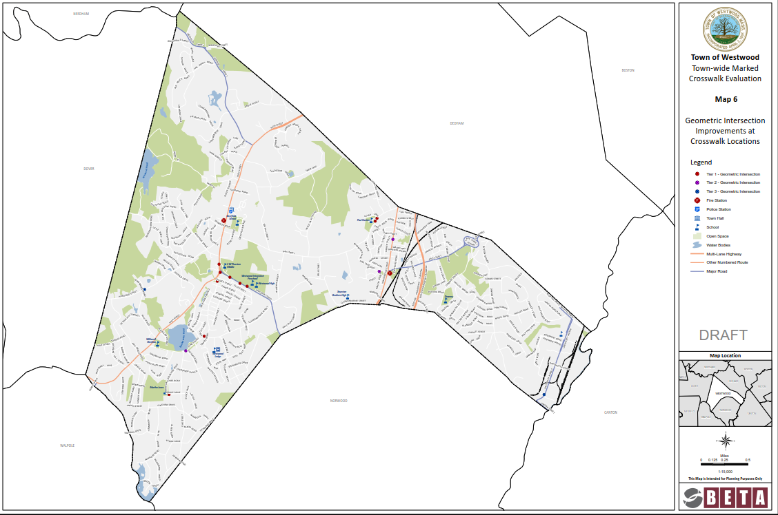

**This Page Intentionally Left Blank**

1. **Cost Estimate**

The cost per Tier is broken up into short term and long term improvements. Short term improvement considerations consist of signing, pavement markings, trimming vegetation, installation of detectable warning panels, adjusting utilities and patching any elevation difference between the ramps and roadway. The long term improvement considerations consist of bump outs and intersection reconstruction. Roadway pavement improvements and vegetation trimming were not included in the cost totals provided in this section. The omission of these is based on conversations with the Town that the improvements will be made as part of the yearly Town programs.

**Tier 1**

The total cost for short term improvement measures in Tier 1 is approximately $165,000 and the total cost for long term improvements is approximately $140,000. The combined estimate in Tier 1 for the short and long term improvements to bring all existing pedestrian crossings into compliance is approximately $305,000.

**Tier 2**

The total cost for short term improvement measures in Tier 2 is approximately $15,000 and the total cost for long term improvements is approximately $165,000. The combined estimate in Tier 2 for the short and long term improvements to bring all existing pedestrian crossings into compliance is approximately $180,000.

**Tier 3**

The total cost for short term improvement measures in Tier 3 is approximately $20,000 and the total cost for long term improvements is approximately $75,000. The combined estimate in Tier 3 for the short and long term improvements to bring all existing pedestrian crossings into compliance is approximately $95,000.

The combined cost for both short term and long term improvements for Tier 1, Tier 2, and Tier 3 is approximately $580,000. The cost estimate breakdown per location is in the Appendix. Any costs necessary for tasks related to engineering services for traffic analysis, design, bidding document preparation, construction oversight, and obtaining rights-of-way are not included in the cost estimation.

**APPENDIX A –Field Photos and Notes**

**APPENDIX B – Evaluation Matrix**

**APPENDIX C –Cost Estimate**