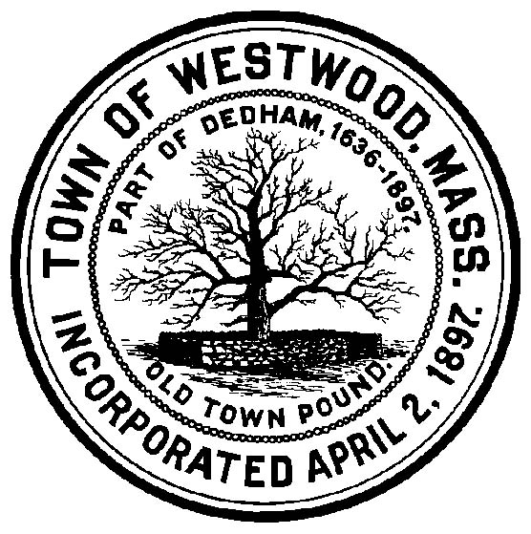
TOWN OF WESTWOOD
COMMONWEALTH OF MASSACHUSETTS

Board of Selectmen
Nancy C. Hyde, Chair | Christopher T. Coleman ICMA-CM, Town Administrator
Michael F. Walsh, Clerk  John M. Hickey, Third Member | Pamela M. Dukeman, Asst. Town Administrator/Finance Dir.  Patricia A. Healey, Interim Executive Assistant
April 28, 2020

Westwood Residents,

The Select Board recently approved three local options to provide more time for the payment of municipal bills, including real estate taxes, personal property taxes, motor vehicle excise taxes and sewer bills.

- The due date for Personal Property and Real Estate taxes has been extended to June 1, 2020.

- The application deadline for tax exemptions and the tax deferral program has been extended to June 1, 2020.

- The Select Board voted to waive any interest or late penalties on fiscal year 2020 municipal bills with a due date of March 10, 2020 or later, provided payment is received on or before June 30, 2020.

For those of you who have your real estate taxes escrowed, please contact your lender if you have any questions regarding the payment of your real estate taxes.

If you have questions, regarding your municipal bill, please contact our Collector’s Office at (781) 320-1015 or by e-mail collectors@townhall.westwood.ma.us and one of our team member’s will respond to your inquiry.

The Annual Town Election will be held on Tuesday June 2, 2020.Polling locations will be open; in addition, you also have options to participate by Early or Absentee ballot. Applications for Early and Absentee voting are available in the lobby of the Westwood Police Station located at 588 High Street or by calling the Town Clerk’s Office at 781-326-3964.

Please continue to practice social distancing and follow our Board of Health’s face covering guidance and together we can continue to help flatten the curve and slow down the spreading of COVID-19.For more information and updates, please visit our website at www.townhall.westwood.ma.us . On behalf of our Select Board and our town employees, “thank you” and stay safe!

Thank you,

Christopher Coleman
Town Administrator
Town of Westwood

