Town of Westwood

Housing Production Plan

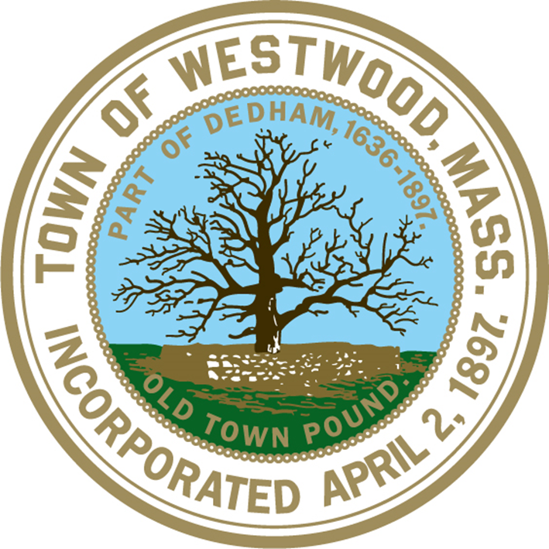

Draft Plan

March 1, 2019

## Prepared By:

**Housing Partnership / Fair Housing Committee**  
Michael McCusker, Chairman  
Cheryl Fay

# Housing Vision

• • •

The Town of Westwood aims to be proactive in its efforts to plan and develop a diversified housing supply that best serves the varied needs of its residents. The Town aims to advance principles of housing choice, sustainability and affordability.

Abraham Glaser

John Hickey

Lou Rizoli

Kate Wynne

Brian Gorman, Alternate

Michael Jaillet, Ex-officio Member & Fair Housing Officer

Sarah Bouchard, Ex-Officio Member

**Department of Community and Economic Development**

Sarah Bouchard, Housing & Zoning Agent

Town of Westwood

50 Carby Street

Westwood, Massachusetts 02090

## Prepared For:

Town of Westwood

580 High Street

Westwood, Massachusetts 02090

Department of Housing & Community Development

100 Cambridge Street

Suite 300

Boston, Massachusetts 02114

## Acknowledgements

The Housing Partnership would like to recognize the efforts and support of the Select Board, town staff, and residents who devoted their time, ideas and participation to the successful creation of this Plan.

Table of Contents

Acknowledgements 2

Introduction 4

About Westwood 4

Housing Needs Assessment 6

Summary 6

Population & Demographic Analysis 6

Housing Supply 10

Constraints on Development 14

Survey 17

Community Visioning Workshop 17

Community Engagement Outcomes 19

Summary of Survey Outcomes 19

Summary of Visioning Workshop Outcomes 23

Housing Vision 25

Housing Production Action Plan 26

Appendices 30

Reference Materials 30

## Introduction

The Town of Westwood has developed this Housing Production Plan in compliance with Massachusetts Department of Housing and Community Development’s 760 CMR 56.03(4), Housing Production Plans. The Plan was developed in coordination with the Town of Westwood Housing & Zoning Division, Housing Partnership, Planning Board, Board of Selectmen, and with input from residents through surveys and community workshops.

Per DHCD guidelines, a Housing Production Plan, or HPP, is a proactive strategy for planning and developing affordable housing. It should be developed with opportunities for the community to become informed of and influence the planning process and outcome. A HPP is an important tool for municipalities to plan for affordable housing development through a diverse housing supply. Municipalities that successfully adopt a proactive approach to development of low and moderate income housing in a HPP are encouraged to execute implementation strategies through at least one significant incentive. HPPs may be certified by DHCD when a municipality that has not yet met its statutory minima on the Subsidized Housing Inventory (SHI) instead meets an interim goal and demonstrates steady progress towards hitting that 10%.

Regardless of the municipality’s position on the SHI, a HPP can serve as a coordinated vision and strategy for housing development, with a particular focus on affordability. Westwood hopes to continue its history of progress and success in affordable housing development, and utilize this HPP to plan for a future that both preserves the Town’s assets and achieves its vision for housing affordability.

## About Westwood

The Town of Westwood is an 11 square mile community in Norfolk County located 12 miles southwest of Boston. The Metropolitan Area Planning Council categorizes Westwood as an “Established Suburb”, which it defines as a residential suburb with mostly single family homes on moderately sized lots, an affluent population, and limited but still present amounts of vacant developable land, multifamily housing, and commercial development.

Westwood boasts a beautiful suburban setting that offers residents access to multimodal transportation, diverse retail and commercial selection, excellence in education and passive recreation opportunities at conservation areas and municipal facilities. It is bordered by the municipalities of Needham to the north, Medfield and Dover to the west, Dedham to the east, and Norwood and Walpole to the south.

Westwood is proud to be “Open for Business”, with over two hundred businesses across town contributing to the Town’s economic health and providing jobs and retail opportunity to residents. The quality of the Town’s schools are recognized statewide with students consistently scoring in top percentiles on MCAS, and the overwhelming majority of students graduating from the high school continue to pursue higher education. Westwood’s residents are conveniently located to both Interstate 95 and Route 1, which both run through the town. The town contains two train stations servicing major hubs; Islington station provides MBTA Commuter Rail service to Boston and Route 128 Station, which serves as the sole regional stop for AMTRAK high speed rail service to Boston, New York City, and Washington, D.C. as well as MBTA Commuter Rail trains to Boston and Providence. MBTA bus service operates on Washington Street through Islington Center with regular service to the MBTA Subway, via the Orange Line’s terminal station at Forest Hills.

The Town of Westwood is governed by the Select Board, which is made up of three members who are elected for three-year overlapping terms. The Town adopted a Home Rule Charter, which provides for the Selectmen, Open Town Meeting, and Town Administrator form of government. The Town of Westwood boasts high quality municipal services, with two libraries, a senior center, Youth & Family Services, first rate police and fire departments, recreational facilities and an array of other services available at Town Hall and Carby Street Offices.

## Housing Needs Assessment

### Summary

The Town of Westwood is a thriving suburban community that has seen significant transition in land use over the course of its nearly 125 year history. The Metropolitan Area Planning Council classifies Westwood as an Established Suburb, characterized by its relatively stable population, scattered vacant parcels, predominant single family home zoning, and new growth in the form of infill or limited redevelopment.

### Population & Demographic Analysis

##### Total Population Changes

Figure 1: Population Change

Westwood experienced sustained, significant growth in the period of time from 1930 and 1970, followed by a brief period of decline in the 1980s and continued growth through 2010 (Census, ACS).

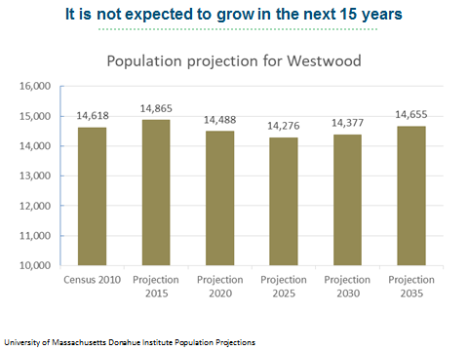

Figure 2: Population Projection

The population has remained stable since then and is not expected to grow in the next 15 years (UMass Donohue Institute Population Projections).

##### Age

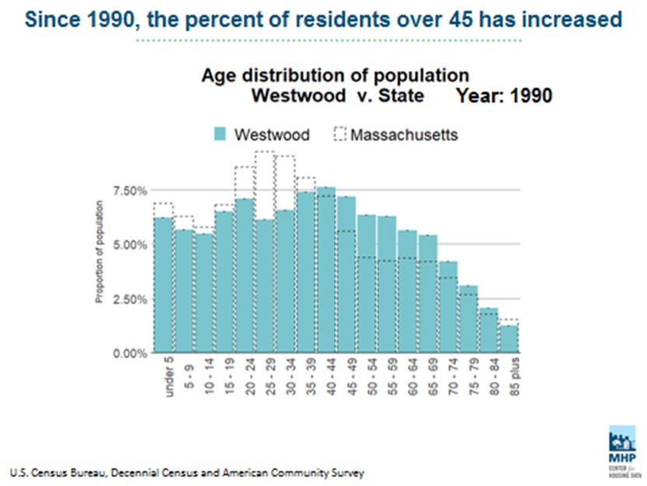Age distribution in a community is an important consideration when evaluating housing supply and planning for future development. The presence or absence of certain age groups when compared to a statewide age distribution can yield valuable information about gaps in the current housing supply. In Westwood, the population has rapidly aged in recent decades.

Figure 3: Age Distribution 1990

The median age increased by 4.7 years between 2000 and 2016, which outpaced the aging of the general statewide population (which only saw a 2.9 year increase).

The percentage of total residents over 45 has increased at a rate that also exceeds that of Massachusetts statewide, with a visible gap of people aged 20-39 that has grown consistently since 1990 (Census).

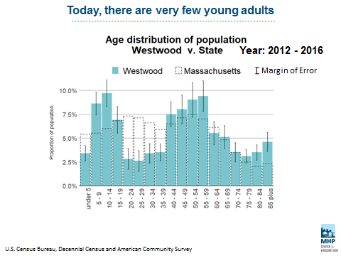

What does this mean for Westwood? A healthy housing market offers a variety of housing options that meet the needs of all market groups, including affordable and flexible options for young adults. If a town’s housing supply does not meet that demand because it is too costly or lacks diversity of housing type, then entire demographic groups may be excluded from representation in the town’s population. According to the ACS, Westwood residents under the age of 4 have also been declining; children aged 0-4 represented 7.80% of the population in 2000 and only 3.4% in 2016 (ACS). The impact of an insufficient housing supply can ripple throughout a community, affecting not only the households excluded from a community but the infrastructure of the community itself as it plans for schools, programs and services. Similarly, with an increase in residents aged 65 and older, Westwood must also plan for meeting the housing needs of seniors, addressing overall supply, affordability, accessibility, and stability for existing residents who wish to remain in their homes.

Figure 4: Age Distribution 2012-2016

##### Race

Westwood’s population is less racially diverse than the statewide population, with 88.2% of residents identifying as white compared to 72.9% overall in Massachusetts (ACS). 8.8% of residents identify as Asian, which is higher than statewide figures of 6.2%. Black or African-American, Hispanic or Latino, or multiracial individuals are all significantly underrepresented in Westwood compared to the general Massachusetts population.

##### C:\Users\sbouchard\Downloads\Westwood Race .png

Figure : Population by Race

It is incumbent upon any municipality to plan for a housing supply that is inclusive to all residents regardless of race, color, national origin, gender, gender identity, sexual orientation, disability, ancestry, genetic information, marital status, veteran or active military status, age, familial status (i.e., children), and source of income (i.e., Section 8 voucher). State and federal law protect the rights of the groups against housing discrimination. Through its town staff and Fair Housing Committee, Westwood is careful to monitor affordable housing distribution against the provisions of the Fair Housing Act, and is prepared to respond as required to allegations of housing discrimination within the community and private market as required by state law. Regardless, decades of exclusionary lending and zoning practices that persisted nationwide prior to the adoption of the Fair Housing Act in 1969 left a wake of racial segregation that persists to this day, particularly in suburban communities like Westwood. Planning for residential development in Westwood must seek to incorporate ways to mitigate inequities rather than perpetuate them. A housing supply that is diverse in affordability and type is most inclusive.

##### Income & Employment

According to ACS data, Westwood’s median household income is almost double the median income statewide, at $140,355 in 2016. Of Westwood’s six adjacent towns, only Needham surpasses Westwood in median household income.

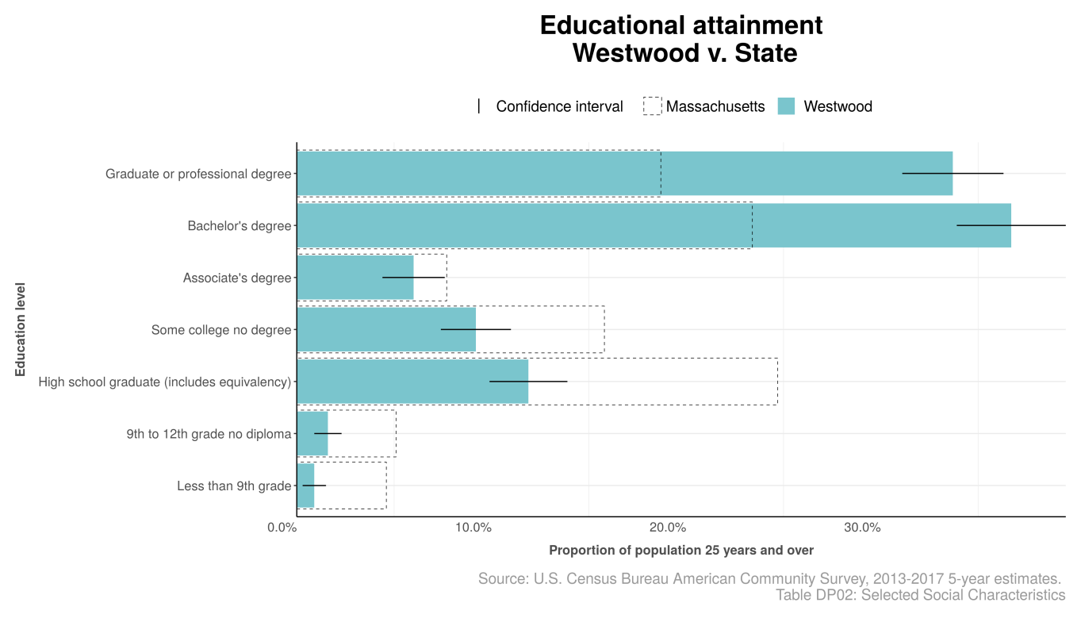Westwood has a highly educated population, with educational attainment of Bachelor’s degrees, graduate and professional degrees dramatically outpacing that of the state, generally. Consequently, labor force participation is also high in Westwood, with lower unemployment rates than the state average and a greater total labor force as a percentage of population.

Figure 6: Educational Attainment

Despite this, a significant percentage of households in Westwood qualify as “cost burdened”, which according to the US Census Bureau, occurs when a household spends more than 30% of its income on housing costs. When a household spends more than 50% of its income on housing costs, it is designated as “severely cost burdened”. This metric demonstrates the nexus of personal wealth with housing affordability; in a market with either limited supply, high home prices, or both, more households are likely to suffer from the cost burden of maintaining a household.

In Westwood, owner households are less cost burdened (17.9%) and severely cost burdened (3.6%) than renter households (24.3% and 16%, respectively), but given that the vast majority of households in Westwood reside in owner-occupied housing (over 86%, ACS), the significance of these figures represent a startling departure from the financial stability one might expect from Westwood’s household income statistics.

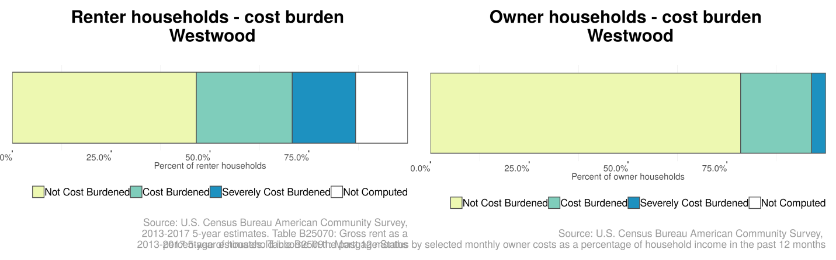

Figure : Cost Burden

### C:\Users\sbouchard\Downloads\Westwood Employment v state .pngHousing Supply

Figure 8: Labor Force Status

##### Zoning

Westwood’s zoning primarily supports low density residential development, although some substantial changes have been made in recent years to promote mixed use and multifamily development in certain targeted areas throughout town. The town is marked in its high degree of variability between neighborhoods, which offer distinctive character. Residential zoning districts diverge significantly, from walkable, transit friendly lots in the General Residence district requiring 12,000 sq. ft. minimum lot sizes to pastoral, estate style lots in Single Residence E requiring 80,000 sq. ft. minimum lot sizes. Seven (7) Flexible Multiple Use Overlay Districts were adopted in recent years and promote commercial and higher density residential development.

Westwood's Zoning Bylaw imposes affordability requirements on all residential developments allowed by Open Space Residential Development (OSRD) special permit or by Flexible Mixed Use Overlay (FMUOD) special permit. These requirements call for 15% of the total number of new housing units to be restricted in perpetuity as affordable, thereby providing a sufficient number of SHI units to support the new special permit development, along with additional units to offset housing units created through by-right development elsewhere in town. The University Station Mixed Use District (UAMUD) section of the Zoning Bylaw also requires the inclusion of affordable housing within any residential component of the University Station Development.

##### Type

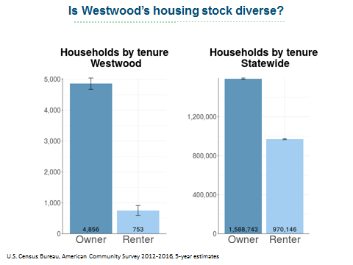Consistent with its zoning, Westwood’s housing stock is predominantly comprised of single family, owner occupied homes. Renters represent a substantially smaller percentage of the town’s population than they do statewide.

Figure 9: Households by Tenure

4,483 out of 5,816 overall housing units were single family homes, according to Assessor records through December 2017. Duplexes, townhomes and multifamily buildings are a significant minority in Westwood’s overall housing composition.

##### C:\Users\sbouchard\Downloads\Westwood Housing stock by type .png

Figure 10: Building Type

##### Affordable Housing & SHI

At present, Westwood currently has met its statutory minima of 10% affordable housing on the state Subsidized Housing Inventory. A total of 576 affordable units represent 10.6% of the town’s total 5,389 year round housing units as reported on the 2010 Census. The current units offer a variety of housing type, bedroom size and programs. Westwood’s SHI portfolio includes rental apartments, single family ownership, age restricted communities, Department of Developmental Services group homes, Westwood Housing Authority duplex rentals, and bedroom sizes ranging from 1-4.

Although the Town has been motivated and proactive in its efforts to promote affordable housing production in its zoning, ongoing residential development coupled with an expiring affordability restriction on a senior housing complex in 2016 has left the Town vulnerable to challenge after many years of SHI compliance. The Town has been responsive to this challenge and is working aggressively to meet its affordable housing goals through the 2020 Census and beyond. As many as 27 additional units are pending permitting or construction at the time of this writing.

##### Housing Vacancy

Vacancy rates are extremely low in Westwood. According to the Massachusetts Housing Partnership, a healthy vacancy rate is typically 7-8% for rental units and 2% for homeownership units and is a sign that a housing market has enough supply to meet demand. Hyper vacancy occurs when vacancy rates significantly exceed those benchmarks, and is a sign of blight and deterioration of a community. Adversely, extremely low vacancy rates are a sign of stagnant housing production and lead to rapid, unsustainable rises in housing costs, particularly rental, and instability in the overall market. In urban areas, homelessness rates also tend to rise when vacancy rates are extremely low. In Westwood, vacancy rates for both rental and ownership have hovered near zero for the last 5-7 years, with brief surges shortly after the construction of multifamily development in the University Station project. Impacts of low vacancy create difficulty in locating & securing housing for residents at all income levels and create barriers to entry for first time homebuyers. Even homeowners not interested in relocation can find themselves impacted by inflated market costs through higher property valuation and taxation.

Affordable housing in particular is in high demand. A quarterly survey of Local Action and Comprehensive Permit units conducted by the Housing & Zoning Division reports a current vacancy rate of less than 1% at the time of application. Waiting lists for affordable units of all sizes stretch to as many as 3 years in multifamily developments.

##### Housing Costs

Westwood’s housing costs The Warren Group reports the current median sale price for a single family home in Westwood as $801,000, up nearly 11% from this same time last year. According to data released by the Warren Group in 2018, the single family homeownership market is suffering from a lack of housing supply as well, with total YTD sales declining by 7% in the last year.

Critically, the Housing Affordability Index for a single family home in Westwood is 90, meaning that the median household income is insufficient to finance the median priced home in Westwood.

68% of Westwood owner-occupied households held a mortgage in 2017. Of these, the median monthly housing cost was $3,165. For nearly 30% of these households, these costs represented over 30% of the households’ gross monthly income (ACS). For households who rent, in 2017 the median monthly rent was $1575 per month. For over 45% of these households, monthly rent exceeded 30% of gross monthly income.

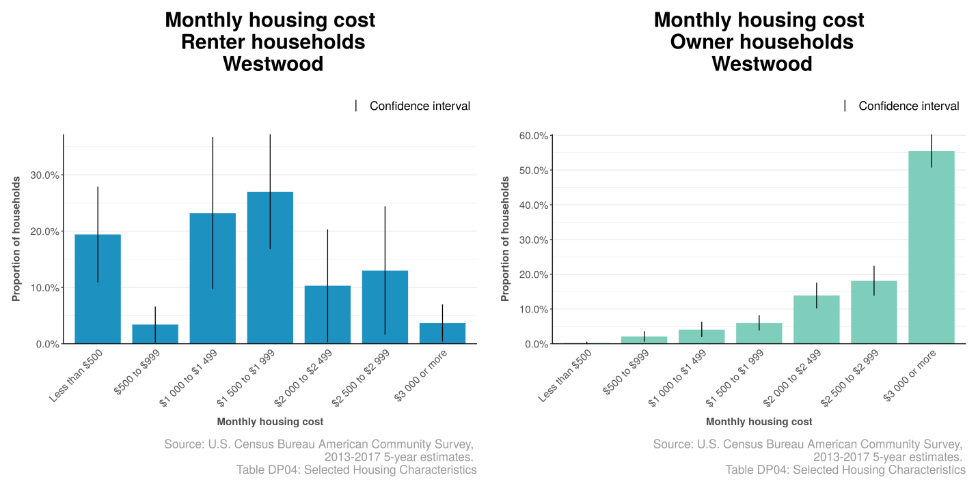

Figure 11: Monthly Housing Cost

### Constraints on Development

##### Market forces

A primary constraint on development is the high cost of land in Westwood. In the last decade, market forces have surged the cost of property higher in both Westwood and surrounding communities. Westwood’s excellent public school system, proximity to transportation, and bucolic setting has made property highly desirable. The Warren Group reports the current median sale price for a single family home in Westwood as $807,500, up nearly 12% from this same time last year. Critically, the Housing Affordability Index for a single family home in Westwood is 90, meaning that the median household income is insufficient to finance the median priced home in Westwood.

Compounding these forces in the single family market is a strong trend toward teardown activity, whereupon more affordable, modest homes are purchased by investors and replaced with significantly more expensive homes. Teardown activity has surged in recent years, leading to an inflation of sales prices for single family homes and reducing the Town’s modest “starter home” stock. In 2017, Town Meeting voted on a series of amendments to the Zoning Bylaw which had the effect of reducing the ability of a nonconforming parcel to further impede into the setbacks; however, teardown activity continues. Vacancy is extremely low and the inventory of single family homes on the market is limited.

##### Conservation Land

Describe total acreage and percentage of land in Westwood designated as protected conservation land/open space. Briefly summarize history of Westwood as agricultural area. Mention Scenic Road bylaw and other protections. Describe community response to Open Space Recreation Plan and establish priority of protecting this land.

##### Traffic/Roadway Infrastructure

Route 109, Washington Street (Route 1A), and Route 1 are three major arterials that travel through Westwood. Western commuters use these three routes as primary sources both during the morning and evening commutes putting a surplus of traffic along these corridors. The Town of Westwood has invested in several studies and measures in trying to assist with traffic flow during these peak time commutes; however, increasing development and population are constant variables that are leading to more traffic. Traffic applications have also put a stress along our primary and secondary roadways as these recommended routes take vehicles through neighborhoods enabling the commuter to get to their final destination quicker.

Increased traffic flow will be something the Town of Westwood has to be constantly looking at and trying to improve. Traffic is an issue; however, the number one concern is pedestrian safety. Any additional development or housing has to result in consideration to pedestrian accommodations, of which can include safer more compliant sidewalks, bicycle lanes, and improvements to all crossing locations. It is imperative all considerations are taken with respect to the afore mentioned concerns not only in Westwood but also the abutting communities that utilize stretches of the Town’s road way and infrastructure daily.

##### Split Tax Rate & Municipal Finance

Given soaring property values in Westwood, real estate tax valuation by the Town has also been affected. FY19 was a full revaluation year, and the value of residential real estate in Westwood increased 5.5% from FY18. As property assessments must reflect market conditions and sales activity, residents are sensitive to property taxes and increasing costs of living.

To alleviate this issue, Westwood currently utilizes a split tax rate, allowing the Town to charge a higher tax rate to commercial properties than it does for residential properties. Over the last 5 years, Westwood has incrementally lowered the residential tax rate from $15.24 to 14.65 per thousand dollars of residential value, and the commercial tax rate has lowered slightly from $28.79 to $28.24 per thousand. Given the considerable impact of commercial value to overall municipal finances, the town has made efforts in recent years to strengthen its commercial property base. The multi-phase, mixed use development at University Station has been a significant achievement toward this goal, increasing commercial value as a percentage of total value from 12.5% in 2015 when University Station opened to 15.97% in 2019. Commercial property in Westwood pays 26.7% of taxes, saving the average homeowner $1,370 or 15% of their tax bill.

Development efforts to expand Westwood’s commercial tax base allow Westwood to preserve and expand its commercial value, reducing the financial strain on residential households. This applies pressure on redevelopment efforts in favor of commercial activity.

##### Other Municipal Infrastructure

Westwood’s Sewer Department is the major functioning utility owned, operated, and maintained by the Town.  There are assessments done regarding potential impacts to the system whenever any newly proposed development or housing comes before the community.  Capacity and flow rates are the primary concerns the Sewer Engineer assesses to ensure neither will become an issue based on the potential increases associated with development.  If there is a concern or a reason to address a potential problem, the Sewer Commissioners will require (based on the scale of the project) a form of mitigation be provided by the developer to ensure the existing infrastructure is not compromised.

 The newly active MS-4 Storm-water permit requires extensive tracking and monitoring by the community.  Run off and outfall testing could constrain development depending upon what the exact plan calls for.  Typical concerns would lie within projected numbers based on amounts of infiltration entering the Town’s system along with what it would cause from an accounting and monitoring standpoint.

(Insert section on public safety services and capacity for residential development) Community Engagement Strategy

Community engagement is an important component of the Housing Production Plan. The Housing Partnership’s goal for community input was to provide a variety of formats and media through which the public could participate. The two tools selected by the Housing Partnership for community engagement were a survey and a community visioning workshop.

### Survey

The survey, titled “A Survey of Housing Needs in Westwood” was published on October 15 and was open for three weeks, closing on November 5. The survey was available to respondents both online and in paper format. The Housing Partnership pursued a wide-reaching marketing strategy to notify the public, with advertisements distributed via the town website, official social media pages (Facebook pages for Planning Board and the Town, Town Twitter), the town’s emailed monthly newsletter Westwood Wire, the town’s weekly Schools Bulletin, Westwood Press and Hometown Weekly newspapers for two consecutive weeks, posters at Town Hall, Carby Street Municipal Building, Westwood Youth & Family Services, Westwood Council on Aging Senior Center, Westwood Library, and twice via town-wide email listserv. The digital survey platform, Responster, was chosen for its ability to adapt easily to mobile phones and tablets in addition to desktop format, in the hopes that ease of use would expand participation.

206 responses to the survey were received and aggregated into digital format.

The survey was divided into three basic sections. The first section was comprised of basic demographic information that sought to compare survey respondents to the overall population of Westwood. Survey respondents answered questions including housing type, years in current home, annual income, and monthly gross housing costs. The second section contained questions about the individual respondent’s current and future housing needs. Questions in this section included whether the respondent was concerned about his/her current housing situation, and if so, why, if there were intentions of moving and to where, and narrative options for personal experiences with housing choice or affordability. The third and final question sought to identify opinions about the current housing inventory and potential development. It gave respondents a chance to identify which housing types were “not enough” or “too many”, identify ideal locations for future development, select qualities for residential development, and provide narrative feedback on housing in Westwood.

### Community Visioning Workshop

A Community Visioning Workshop was held at the Downey School Cafeteria on November 13, 2018 at 7 pm. The location was selected for accessibility, capacity, and suitability respective to AV needs and parking. The workshop was open to the public and was advertised using the same diverse marketing strategy to notify the public, with advertisements distributed via the town website, official social media pages (Facebook pages for Planning Board and the Town, Town Twitter), the town’s emailed monthly newsletter Westwood Wire, the town’s weekly Schools Bulletin, Westwood Press and Hometown Weekly newspapers for two consecutive weeks, posters at Town Hall, Carby Street Municipal Building, Westwood Youth & Family Services, Westwood Council on Aging Senior Center, Westwood Library, and twice via town-wide email listserv.

About 25 participants attended. The workshop opened with a welcome from the Chairperson of the Housing Partnership and a presentation by the Housing & Zoning Agent on preliminary highlights of the Needs Assessment, survey responses, and a general overview of Chapter 40B. Attendees then participated in a series of small group discussion exercises led by the Housing & Zoning Agent. Group exercises were designed to foster collaborative discussion of the town's vision for housing and strategy for affordable housing production. Small groups were selected at random upon participants’ arrival at the workshop, and the groups were led by members of the Housing Partnership and volunteers from the Planning Board and Comprehensive Plan Steering Committee. During each exercise, a discussion prompt was introduced by the Housing & Zoning Agent and then group leaders were tasked with facilitating and recording input on paperboards or maps provided for each question. Group leaders diligently worked to ensure inclusive conversation, where each participant was given the opportunity to share thoughts. At the close of the assigned time, groups shared brief summaries of their work with the larger group. The six exercises included the following discussions:

1. Introductions: Name, Neighborhood, What brought you to Westwood? Why have you stayed?
2. Perfect World: What does a successful housing market in 2035 look like?
3. Obstacles: Difficulties and challenges to the “perfect world” described previously
4. Strategies: Drawing on best practices, what ideas could serve Westwood’s unique needs?
5. Strategic Zoning: Mapping the town for strategic regulatory changes that encourage affordable housing
6. Parcel Mapping: Mapping the town to identify parcels for Comprehensive Permits

Throughout the drafting of the plan, a page was created on the town’s website to provide ongoing updates on the Housing Production Plan. Meeting materials and recordings were uploaded to the page and feedback was openly solicited via the office of the Housing & Zoning Agent.

## Community Engagement Outcomes

Consistent themes throughout the various forms of community engagement showed support for increased affordable housing production and overall housing affordability.

### Summary of Survey Outcomes

Of the 206 respondents to the survey, an overwhelming majority (91%) resided in single family homes, and 89% owned their homes, which is representative of the total population, with ACS data showing over 80% of Westwood’s housing stock populated by detached single family homes and a rental rate of 13.4% (US Census Bureau, 2012-2016 5 Year Estimates). Survey respondents skewed heavily toward higher household incomes as well, mirroring statistical analysis for the general population found in the needs assessment.

Figure 12: Survey Housing Tenure

Despite what might be considered as measures of relative housing stability (high household income and single family home ownership), a significant percentage of survey respondents (33%) indicated that they were concerned about their household’s ability to maintain its current housing, with affordability a leading cause, followed by the ability to pay for maintenance and improvements, the ability to locate next housing, and ability to live independently due to health/mobility.

Figure 13: Survey Household Income

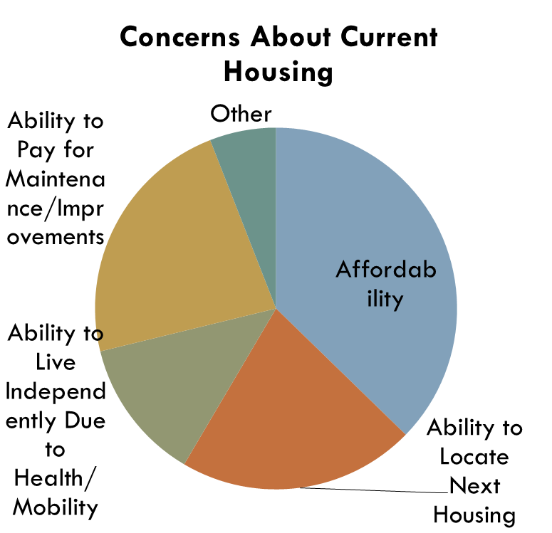

In this area, survey responses supported and were supported by needs assessment data showing that despite relatively high economic factors such as household income and homeownership, a greater proportion of homeowners are cost burdened compared to the state.

Figure 14: Survey Concerns about Housing

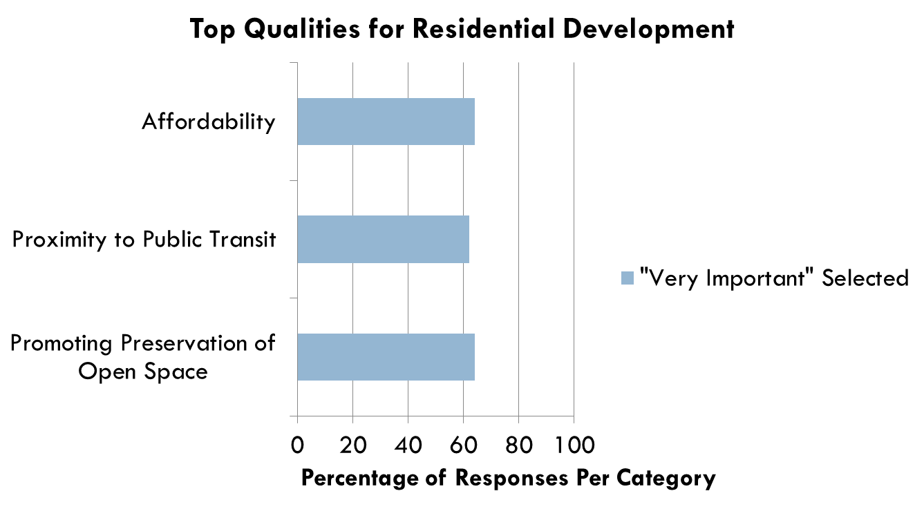When asked to assess the current housing supply, survey respondents indicated preference for affordability and increased housing type diversity. Respondents to the survey demonstrated strong support in favor of affordable single family homes, with 74% of respondents indicating that there are not enough single family starter homes in Westwood today. 71% felt there are too many luxury single family homes. More moderate but still significant groups (40%-57%) felt there are not enough duplex/3 family homes, condos, apartments, subsidized/affordable homes, and senior housing.

Figure 15: Survey Qualities for Residential Development

When considering top qualities for residential development, the three attributes receiving top marks as “Very Important” were Affordability, Proximity to Public Transit, and Promoting Preservation of Open Space.

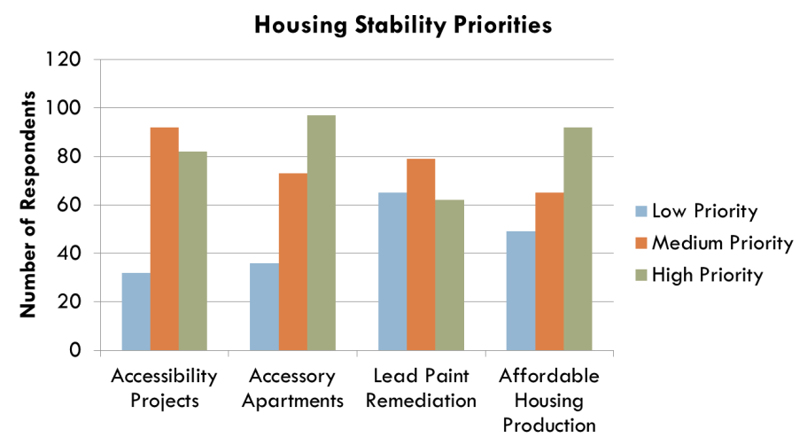In a series of questions about housing stability measures, respondents were asked to weigh in on how the Town should prioritize funds, programs and initiatives that aimed to help keep people housed in their current homes and/or in Westwood generally. Outcomes showed that survey respondents felt strongly in favor of accessory apartments and affordable housing production. Westwood currently has an accessory apartment or accessory dwelling unit program that allows such units up to 2% of total dwelling units (currently about 100) in the form of a special permit.

Figure 16: Survey Housing Stability Priorities

The survey offered opportunity for respondents to provide their thoughts on housing needs in narrative format. Generally, the comments submitted by respondents provided a thoughtful, provocative view on the current state of Westwood’s housing supply and anticipated personal housing related needs.

“Considering downsizing…worried there are not enough medium to small homes that are reasonably priced”

Many people expressed concern about their continued ability to pay for housing in Westwood, stating that a retiree’s income was insufficient to keep up with property taxes or that there were limited opportunities to downsize while still staying in the community. Some seniors expressed that their children were unable to afford to live here with their families.

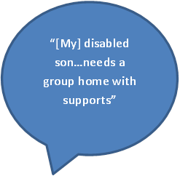Multiple respondents discussed the need for increased supportive housing in the community, describing the needs of their children with disabilities and their own concerns about their children being cared for in perpetuity. Group home development was supported in several comments.

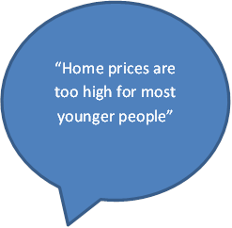Still others expressed their views on a lack of affordability for young families. Respondents discussed the strength of the school system as a draw but shared that there were limited options for families to move out of their starter homes to houses that fit their growing families. Others described an environment where young families could not afford to make the jump from rental to purchasing their first homes. Comments also discussed the needs of divorced families attempting to secure affordable housing in order to keep their children in their current schools.

“My son and his wife would like to live in Westwood but housing prices are too high”

“We will be sad to leave”

“We have enjoyed the community and appreciate commitment to schools…we may be priced out of our home”

“I will probably need to move out of Town to find the housing I need”

“We are dismayed by the large number of tear-downs, removing affordable sized houses”

“Divorcing parents are struggling to keep their children in district”

“Affordability is a deterrent”

“I love this town”

### Summary of Visioning Workshop Outcomes

The community visioning workshop was an opportunity for participation by residents, and attendees took advantage through robust small group discussion and brainstorming. Attendees were divided into three groups at random and a group leader captured the discussion of each. Although the groups had ideas and visions as unique as the individuals within them, there were strong themes throughout the workshop.

When envisioning a successful Westwood and housing market in the future, the groups spoke often about intergenerational living. Participants imagined a Westwood where residents at all stages of life could find a home, both young and old, and where residents could return to the Westwood they grew up in as children. Their “Perfect Westwood” included ample open space and preservation of existing resources, and where neighborhoods were highly walkable and strongly defined. Groups envisioned vibrant communities where people could both work and live and where diversity thrived and was honored as a community value. Groups found consensus in imagining a Westwood where the sense of community was strong, and thought of neighborhoods made stronger through increased density and smaller lots for starter family homes.

The groups transitioned to a discussion of obstacles and challenges relative to their housing visions. All expressed concern about market forces driving what they considered to be undesirable market activity, driving up housing costs and pricing residents out of the community. All identified teardown activity as both a consequence and cause of concern when thinking about the community as a whole. Groups wondered if private developers had enough incentive to construct the styles of housing they thought Westwood needed, and some expressed concern that the town’s Zoning Bylaws did not sufficiently allow or incentivize residential development that would meet their housing goals. The need to increase the commercial tax base was a discussion point of groups as well, and groups also identified such challenges as public resistance to density, government commitment, drive-through traffic from other towns, and racism and discrimination as obstacles to meeting their housing goals.

The groups reached consensus on a variety of strategies and tools to combat these obstacles. Each thought the Zoning Bylaw would be a useful tool for expanding and incentivizing the kind of housing they thought Westwood needed: starter homes, low rises, duplexes, age restricted housing, and cluster development. Groups discussed innovation in procurement and use of funding sources to construct affordable housing, such as Community Preservation Act, permitting incentives and fees, nonprofit developers and public/private partnerships, tax incentives and land trusts. Participants debated an array of strategies to discourage teardown activity that ranged from complete prohibition to time delay regulation or fees.

Identified sections of town that groups believed to be appropriate for their ideas included many of the existing overlay districts along 1A and Route 1, the former Westwood Lodge parcel, 22 Everett Street parcel, and more.

Each group’s written materials have been included in the Appendices section of this report.

## Housing Vision

The Town of Westwood holds firm its commitment to such guiding principles as housing choice, sustainability and affordability. It seeks to sustain its long history of compliance with Chapter 40B through dynamic development that best meets the needs of the Town and region.

Through this Housing Production Plan, the Town envisions a collaborative effort that engages all stakeholders to meet its affordable housing goals: residents, elected officials, commerce, and municipal staff will plan and develop a diversified housing supply that provides housing of choice for all residents regardless of age, ancestry, color, disability, family status, genetic information, marital status, national origin, race, gender identity, or sexual orientation. This collaboration is demonstrated in the wide scope of support it has already received, through the efforts of the Housing Partnership, a dedicated group of residents appointed by the Select Board, through a vote of support for the Housing Production Plan from the Select Board, and through the involvement and input of the community who contributed to this Plan through the survey and visioning workshop.

The Housing Production Plan proposed to build upon existing successes to reach such goals as increased diversity, preservation of open space, and expanded housing of choice for first time homebuyers, low and moderate income households, seniors, and the disabled. The Plan gives priority to those strategies that support regional planning efforts of housing production and land/water conservation, as well as the sustainability principles set forth by DHCD. Together, these strategies support the overall vision for affordable housing production in Westwood.

Housing Production Plan Goals

1. Encourage single family home development/preservation for first time and low/moderate income homebuyers
2. Develop supportive housing for people with disabilities
3. Promote housing stability initiatives for seniors
4. Increase number of affordable rental and ownership units for seniors
5. Encourage housing development in ways that protect open space and conservation land
6. Seek equitable distribution of affordable units throughout Town that seeks to resolve, not perpetuate, discriminatory housing development patterns
7. Meet and exceed Subsidized Housing Inventory statutory minima in 2020
8. Pursue initiatives that support regional needs and planning collaborations
9. Preserve and expand existing deed restricted affordable housing units

## Housing Production Action Plan

At the time of this writing, the Town of Westwood has currently met its statutory minima obligation under MGL Chapter 40B. 10.91% of the town’s year-round housing units are currently deed-restricted as affordable. Its portfolio of affordable housing is wide ranging in tenure and type. Units designated as rental, ownership, family, elderly/disabled, group home, public and privately owned are represented on Westwood’s Subsidized Housing Inventory.

When the 2020 Census is released, Westwood anticipates that the total year-round housing units will increase due to market development over the last ten years. Westwood currently has a number of affordable projects in progress, with the potential for at least 25 units already permitted or in the permitting process and anticipated to come online in the next 2 years. The Town’s current goal is to maintain its compliance and stay above 10% after the 2020 Census is published. However, a preliminary review of building permit activity over the last decade shows that even if Westwood falls below 10%, the intermediate goals published by DHCD (27 added units of affordable housing, representing a .5% increase or 54 added units, a 1.0% increase) would be well above the threshold necessary to achieve full compliance with Chapter 40B.

This Housing Production Plan sets forth a strategy to maintain its compliance with 40B, but it is also intended to serve as a comprehensive strategy for overall housing affordability, accessibility, and community development. Westwood’s history of success in compliance with Chapter 40B already includes such progressive and dynamic approaches as inclusionary zoning, an active Housing Partnership and Housing Authority, public/private partnerships for development, an Open Space Residential Development bylaw, mixed-use zoning, and an accessory dwelling unit bylaw. This Housing Production Plan seeks to expand upon these practices to meet its housing goals.

|  |  |  |  |  |  |
| --- | --- | --- | --- | --- | --- |
| Goal | Objective | Responsible Entities | | Completion Date | |
|  |  |  |  | | |
| Goal 1: Encourage single family home development/preservation for first time and low/moderate income homebuyers | Consider zoning amendments to discourage teardown of existing “starter homes”  Consider zoning amendments that reduce lot sizes to encourage construction of modestly priced and sized single family homes  Study zoning amendments to expand by right construction of low rise development in additional districts/overlays  Study zoning amendments to expand by right construction of two and three family home development in additional districts/overlays  Advise and study a future Community Preservation Act campaign to grow funds for housing development, historic preservation and open space preservation |  | | |  |
| *Goal 2: Develop supportive housing for people with disabilities* | Partner with DDS providers to secure land and deed restrict for supportive housing and group homes |  |  | | |
|  |  |  |  | | |
|  |  |  |  | | |
| *Goal 3: Promote housing stability initiatives for seniors* | Expand capacity for accessory apartment production  Pursue CDBG funds for housing stability programs to include accessibility grants/loans for income qualified seniors and similar initiatives |  |  | | |
| *Goal 4: Increase number of affordable rental and ownership units for seniors*  *Goal 5: Encourage housing development in ways that protect open space and conservation land*  *Goal 6: Seek equitable distribution of affordable units throughout Town that seeks to resolve, not perpetuate, discriminatory housing development patterns*  *Goal 7: Meet and exceed Subsidized Housing Inventory statutory minima in 2020*  *Goal 8: Pursue initiatives that support regional needs and planning collaborations*  *Goal 9: Preserve and expand existing deed restricted affordable housing units* | Expand capacity for accessory apartment production  Create partnerships with nonprofit developers to invest in creatively financed projects that serve lower income households  Expand capacity for accessory apartment production  Expand existing Open Space Residential Development bylaw to encourage increased use, affordable production, and land preservation by considering reducing minimum tract requirements, minimum lot size, requirements, etc.  Study zoning amendments to expand by right construction of low rise development in additional districts/overlays  Study zoning amendments to expand by right construction of two and three family home development in additional districts/overlays  Advise and study a future Community Preservation Act campaign to grow funds for housing development, historic preservation and open space preservation  Expand inclusionary zoning requirements  Work with WHA/WAHA to implement compliant marketing plans that allow for full inclusion of affordable units on the SHI  Establish an incentive program for developing affordable housing for selected parcels  Study option for deed restriction of affordable accessory apartments  Partner with WAHA/WHA and Housing Trust to develop affordable rentals  Work with WHA/WAHA to implement compliant marketing plans that allow for full inclusion of affordable units on the SHI  Establish an incentive program for developing affordable housing for selected parcels  Continue to participate in regional planning efforts that address housing development, which as Three Rivers Interlocal Council and Metropolitan Area Planning Council  Work with WHA/WAHA to explore additional funding streams and grants for small housing authority capital projects and operating expenditures |  |  | | |

## Appendices

### Reference Materials

Figure 1: Population Change 6

Figure 2: Population Projection 6

Figure 3: Age Distribution 1990 7

Figure 4: Age Distribution 2012-2016 7

Figure 5: Population by Race 8

Figure 6: Educational Attainment 9

Figure 7: Cost Burden 10

Figure 8: Labor Force Status 10

Figure 9: Households by Tenure 11

Figure 10: Building Type 12

Figure 11: Monthly Housing Cost 14

Figure 12: Survey Housing Tenure 19

Figure 13: Survey Household Income 19

Figure 14: Survey Concerns about Housing 19

Figure 15: Survey Qualities for Residential Development 20

Figure 16: Survey Housing Stability Priorities 20

Zoning Map 31

Town of Westwood Zoning Bylaw, Section 5.2 Table of Dimensional Requirements 32

Community Visioning Session Materials: Introductions 35

Community Visioning Session Materials: Perfect World 36

Community Visioning Session Materials: Obstacles 37

Community Visioning Session Materials: Strategies 38

Community Visioning Session Materials: Strategic Zoning 39

Community Visioning Session Materials: Parcel Mapping 40

Zoning Map

(See Attached)

Town of Westwood Zoning Bylaw, Section 5.2 Table of Dimensional Requirements

**5.2 TABLE OF DIMENSIONAL REQUIREMENTS****1**

|  |  |  |  |  |  |  |  |  |  |  |
| --- | --- | --- | --- | --- | --- | --- | --- | --- | --- | --- |
|  | **DISTRICTS** | **DIMENSIONAL REQUIREMENTS** | | | | | | | | |
|  |  | **Minimum**  **Lot Area**  **(sq ft)** | **Minimum**  **Lot Frontage**  **(feet)** | **Minimum**  **Lot Width**  **(feet)** | **Minimum Nonwetland Area2**  **(sq ft)** | **Minimum Front Setback3**  **(feet)** | **Minimum Side Yard Setback4**  **(feet)** | **Minimum Rear Yard Setback4**  **(feet)** | **Maximum Building Coverage**  **(%)** | **Maximum Impervious Surface**  **(%)** |
| 5.2.1 | **SRA** | 12,000 | 90 | 90 | 12,000 | 25 | 15**5** | 30**6** | 25 | 50 |
| 5.2.2 | **SRB13** | 20,000 | 90 | 90 | 15,000 | 25 | 15**5** | 30**6** | 25 | 50 |
| 5.2.3 | **SRC13** | 40,000 | 125 | 125 | 30,000 | 40 | 20**7** | 30**8** | 25 | 50 |
| 5.2.4 | **SRD** | 15,000 | 90 | 90 | 12,000 | 25 | 15**5** | 30**6** | 25 | 50 |
| 5.2.5 | **SRE13** | 80,000 | 175 | 175 | 60,000 | 40 | 20**7** | 30**8** | 25 | 50 |
| 5.2.6 | **GR** | 12,000 | 90 | 90 | 12,000 | 25 | 15**5** | 30**6** | 25 | 50 |
| 5.2.7 | **SR** | 80,000 | 175 | 175 | 60,000 | 40 | 20**7** | 30**8** | 25 | 50 |
| 5.2.8 | **LBA** | 4,000 | 40 | 40 | 4,000 | 10 | 15**9** | 15 | 25 | 80 |
| 5.2.9 | **LBB** | 4,000 | 40 | 40 | 4,000 | 0 | 15**9** | 15 | 25 | 80 |
| 5.2.10 | **HB** | 10,000 | 100 | 100 | 10,000 | 50 | 15 | 15 | 50 | 80 |
| 5.2.11 | **I** | 40,000 | 200 | 200 | 12,000 | 50 | 15**10** | 15**11** | 50 | 80 |
| 5.2.12 | **IO** | 40,000 | 200 | 200 | 12,000 | 50 | 15**10** | 15**11** | 50 | 80 |
| 5.2.13 | **ARO** | 80,000 | 175 | 175 | 60,000 | 50 | 30**12** | 30 | 30 | 50 |

**5.3 NOTES FOR TABLE OF DIMENSIONAL REQUIREMENTS**

1 Shall not apply to sewage pumping stations operated by the Town.

2 The term “Nonwetland Area” shall mean land other than the fresh water wetland as that term is defined in M.G.L. Chapter 131, Section 40. The Minimum Nonwetland Area shall be measured in contiguous square feet. The Minimum Nonwetland Area requirement of 12,000 square feet in all Residential Districts shall apply to all lots created prior to the date of adoption of this provision. M.G.L. Chapter 40A, Section 6 may also limit the requirements for certain other lots.

3 The minimum front setback distance shall be measured from the nearest street line; provided, however, that where the street has a right-of-way width of less than forty (40) feet, the setback distance shall be measured from a line on the lot twenty (20) feet from and parallel to the center line of said street.

4 The minimum side yard and rear yard setbacks shall be the minimum horizontal distance from the lot line to the nearest point of a building or structure.

5 Except that a portion of any building or structure not exceeding fifteen (15) feet in height shall be set back a minimum of ten (10) feet from the side lines of its lot, and a detached accessory building or structure having a height of less than fifteen (15) feet and a front setback of at least seventy-five (75) feet shall be set back a minimum of three (3) feet from the side lines of its lot.

6 Except that a detached accessory building or structure having a height of less than fifteen (15) feet shall be set back a minimum of three (3) feet from the rear line of its lot.

7 Except that a portion of any building or structure not exceeding fifteen (15) feet in height shall be set back a minimum of fifteen (15) feet from the side lines of its lot, and adetached accessory building or structure having a height of less than fifteen (15) feet and a front setback of at least one hundred (100) feet shall be set back a minimum of six (6) feet from the side lines of its lot.

8 Except that a detached accessory building or structure having a height of less than fifteen (15) feet shall be set back a minimum of six (6) feet from the rear line of its lot.

9 Unless the wall facing a side lot line is either a party wall or, if adjoining another lot in the same district, a wall with its outer face coincident with such line. The space between buildings or structures, if any, shall not be reduced to less than fifteen (15) feet.

10 Except that if the side yard abuts a railroad right-of-way, there shall be no minimum side yard setback.

11 Except that if the rear yard abuts a railroad right-of-way, there shall be no minimum rear yard setback.

12 Each side yard setback shall be increased by one (1) foot for each foot that the height of the building exceeds fifteen (15) feet; provided always that the side yards shall total not less than forty (40) percent of the lot width.

13 See Section 8.3 OPEN SPACE RESIDENTIAL DEVELOPMENT for density and dimensional requirements for OSRD.

Community Visioning Session Materials: Introductions

Community Visioning Session Materials: Perfect World

Community Visioning Session Materials: Obstacles

Community Visioning Session Materials: Strategies

Community Visioning Session Materials: Strategic Zoning

Community Visioning Session Materials: Parcel Mapping