**Resident Volunteer Form for Comprehensive Plan Committee**

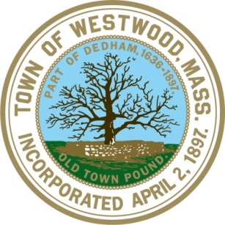

Westwood is updating the Comprehensive Plan beginning this fall through the fall of 2019.  The Comprehensive Plan is a long-range land use policy document explaining what the community is like today, where it wants to go in the future, and how it can get there.  The Plan takes an all-inclusive approach to communicate the community’s vision and strategies to reach its goals.  The Town is seeking candidates to serve on the Steering Committee who have an interest and expertise in one or more of the below subject areas.  We need your help with this update!

Are you interested in serving on the Comprehensive Plan Committee? If you would like to get involved, please complete this form and send it back in along with a letter of interest, resume, and writing samples. Committee members will be expected to write a portion of the plan based on resident input. Please apply and submit by **Friday, October 12**.

**Name:**  **Telephone:**

**Address: Email:**

I’m Interested In: *(Please pick one or rank your specific interest)*

Land Use Economic Development

* 
* 
* 

Town Centers Natural & Cultural Resources

Housing Open Space & Recreation

* 
* 

Community Facilities Transportation

* 
* 

Resilience & Sustainability Implementation

* 
* 

What special skills do you have that will assist in the process?

Describe an experience you have had working with a group of people to write a consensus document or statement.

What do you like most about living in Westwood?

Brief Statement of what you can contribute to the Comprehensive Plan Steering Committee:

Submit the application form, a letter of interest, resume, and writing samples to:

**Mail to:** **Email to:**

Town Hall selectmen@townhall.westwood.ma.us

c/o Selectmen’s Office fax to:

580 High Street (781) 329-8030  
 Copy to: amccabe@townhall.westwood.ma.us

If you have further questions and for more information please contact Town Planner Abby McCabe at amccabe@townhall.westwood.ma.us and (781)-251-2581.

Please visit the Town’s website at the below link to learn more about the Comprehensive Plan Update, duties of the Steering Committee, and the 2018-2019 planning process.

<http://www.townhall.westwood.ma.us/gov/depts/commdevdepts/plandiv/comprehensive_plan/default.htm>

To receive notifications for public meetings and events related to the Comprehensive Plan Update:

<https://public.govdelivery.com/accounts/MAWESTWOOD/subscriber/new>